Architecture Design Document

Template

Leva Devi P2P Lending Platform

Architecture Design Document Template

Document Review and Version Control

Sl no. | Date of Creation | Version No. | Author(s) | Reviewer(s) | Approver | Comments
1 | 04-Aug-2025 | 0.1 | Sulekha K
2 | 22-Jan-2026 | 1.0 | Sulekha K
3

Contents
1. Introduction and Goals 4
1.1. Requirements Overview 4
1.2. Quality Goals 11
1.3. Stakeholder 17
2. Architectural Constraints 18
3. Context and Scope 23
3.1. Business Context 24
3.2. Technical context 29
4. Solution Strategy 34
5. Building Block View 39
5.1. Whitebox Overall System 39
5.2. Level 2 46
5.2.1 White Box: Credit Risk & AI Service 46
5.3. Level 3 51
6. Runtime View 54
7. Deployment View 57
7.1. Infrastructure Level 1(Production Environment - AWS India Region) 57
7.2 Infrastructure Level 2 61
8. Crosscutting Concepts 63
9. Architecture Decisions 67
10. Quality Requirements 74
10.1. Quality Requirements 74
10.2. Quality Scenarios 75
10.2.1 Usage Scenarios (Runtime Quality) 75
10.2.2 Change Scenarios (Evolvability Quality) 76
11. Risks and Technical Debt 77
12. Glossary 79

Peer to Peer Lending

The only good loan is one that gets paid back

Introduction and Goals
This section describes the driving forces that the software architects and the development team must consider for the Leva Devi Peer-to-Peer (P2P) Lending Platform. These include the underlying business goals, essential features, quality goals for architecture, and the relevant stakeholders with their expectations.

Requirements Overview
The Leva Devi P2P Lending Platform is designed to connect Indian borrowers with global lenders (holding valid NRO accounts in India), operating in strict compliance with RBI and FEMA guidelines. The platform aims to be a fully digital ecosystem for onboarding, loan matching, and repayment, leveraging AI for enhanced credit risk assessment and lender analytics.

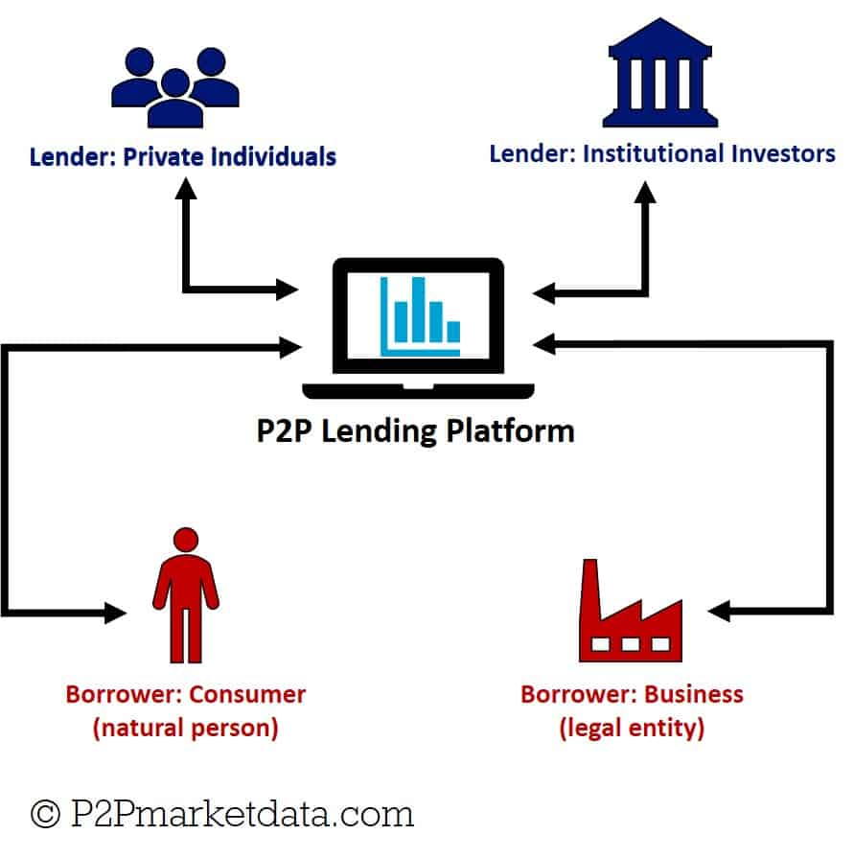
Key objectives include:
- User Acquisition & Retention: Provide an intuitive and reliable platform for both lenders and borrowers, ensuring ease of use across multiple devices.
- Operational Efficiency: Automate core processes like application processing, credit assessment, and repayment tracking.
- Regulatory Compliance: Adhere strictly to RBI guidelines for P2P lending in India, ensuring data privacy, security, and transparent operations.
- Scalable Growth: Support a rapidly increasing user base and transaction volume with minimal operational overhead.
- Financial Innovation: Leverage AI for advanced credit risk assessment and lender analytics.
- Trust & Security: Build trust among users by ensuring the highest levels of data security, payment integrity, and dispute resolution mechanisms.
Assumptions:
- Only Indian residents can borrow via the platform, in line with RBI's NBFC-P2P guidelines.
- Lenders may be Indian residents or global investors with valid NRO accounts in India and earn interests.
- Fully digital onboarding, matching, and repayment through an RBI-compliant ecosystem using escrow and trustee models.
- The platform must ensure KYC, AML, and credit checks for all users using verified third-party services.
- Loan disbursement and repayments occur through regulated banking partners.
- The platform is accessible via web and mobile (Android/iOS).
- Compliance reports must be generated periodically for auditing and regulatory submission.

Advantages:
- P2P lending platforms typically provide higher returns than traditional savings accounts or fixed-income products due to the higher interest rates paid by borrowers.
- Investors can reduce risk by diversifying their portfolios across multiple loans or baskets of loans.
- P2P lending offers an alternative investment option, providing access to a unique asset class with potential for consistent returns.
- Investors can choose loans aligned with their risk tolerance and preferences, offering greater control over their investments.

Disadvantages:
- Borrower defaults can result in capital loss, even with thorough risk assessments.
- P2P loans are often illiquid, making it challenging to exit early unless a secondary market is available.
- P2P lending platforms face risks like operational failure, fraud, regulatory changes, and financial instability, which can disrupt operations and affect returns. Bankruptcy could jeopardize investments, even if loans are being repaid.
- Unlike traditional bank accounts, P2P investments typically lack deposit insurance, exposing investors to potential losses.
High-Level Functional Requirements:
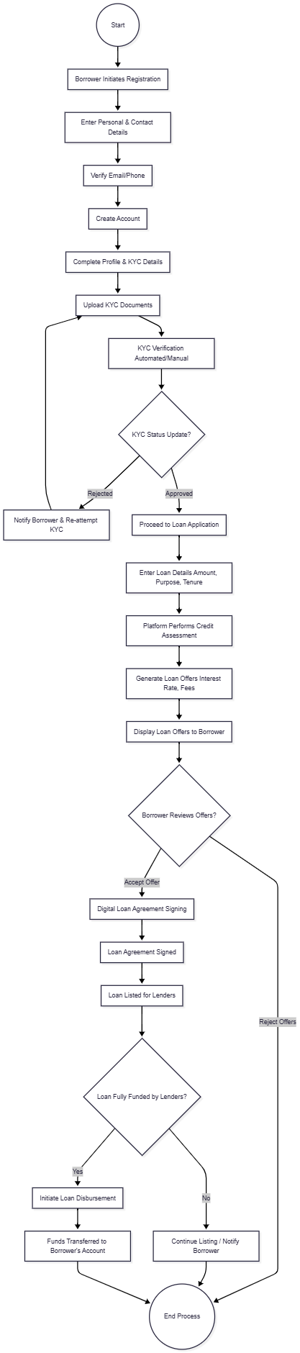
1. Borrower Requirements
- UR-B-001: Self-Registration: Be able to register for an account on the platform using a simple, guided process (e.g., email/phone, OTP verification).
- UR-B-002: Secure Profile Management: Securely manage and update my personal information, contact details, and change my password.
- UR-B-003: KYC Document Submission: Be able to easily upload and submit all required Know Your Customer (KYC) documents (e.g., Aadhaar, PAN, bank statements, proof of address) through a secure interface.
- UR-B-004: KYC Status Tracking: Be able to track the real-time status of my KYC verification (e.g., Pending, Under Review, Approved, Rejected) and receive notifications regarding its outcome.
- UR-B-005: Online Loan Application: Be able to complete and submit an online loan application form, specifying the desired loan amount, purpose, and preferred repayment tenure.
- UR-B-006: Credit Risk & Interest Rate Display: Clearly view the platform's assessment of my credit risk and the assigned interest rate after my application is processed.
- UR-B-007: Loan Offer Review & Selection: Be able to view a list of available loan offers from various lenders, compare their terms (e.g., interest rate, tenure contributions), and select the most suitable offer.
- UR-B-008: Loan Acceptance & Agreement: Be able to formally accept a chosen loan offer and digitally sign the loan agreement.
- UR-B-009: Loan Disbursement Notification: Receive a clear notification (SMS/email) once the loan amount has been successfully disbursed to my linked bank account.
- UR-B-010: EMI Schedule Access: Access a detailed EMI (Equated Monthly Installment) schedule, including due dates, principal, and interest breakdowns.
- UR-B-011: Repayment Tracking: Track my past EMI payments, view my outstanding loan balance, and see a history of my transactions.
- UR-B-012: Payment Method Options: Have various secure options to make my periodic EMI payments (e.g., UPI, Net Banking, Debit Card, NACH mandate set-up).
- UR-B-013: Payment Holiday Request: Be able to formally request a "payment stop" for a single month, understanding that this is subject to lender approval and may affect my platform credit score.
- UR-B-014: Platform Credit Score Visibility: Be able to view my current platform-generated credit score and understand how my repayment behavior (including payment holidays) impacts it.
- UR-B-015: Support & Grievance Redressal: Have access to customer support and a clear process for lodging grievances or queries.
- UR-B-016: Multi-Device Accessibility: Access all platform functions seamlessly and consistently from my mobile phone, tablet, or desktop browser.
- UR-B-017: Data Privacy & Security Assurance: Be assured that my personal and financial data is kept private, secure, and handled in compliance with RBI regulations.
2. Lender Requirements
- UR-L-001: Self-Registration: Be able to register for an account on the platform using a simple, guided process.
- UR-L-002: Secure Profile Management: Securely manage and update my personal/entity information, contact details, and change my password.
- UR-L-003: KYC Document Submission: Be able to easily upload and submit all required KYC documents (e.g., PAN, bank account details, proof of address, source of funds) through a secure interface.
- UR-L-004: KYC Status Tracking: Be able to track the real-time status of my KYC verification and receive notifications regarding its outcome.
- UR-L-005: Fund Deposit: Be able to securely deposit funds into my platform account for lending purposes.
- UR-L-006: Browse Loan Listings: Browse a comprehensive list of approved borrower loan applications, filtering by criteria such as credit risk rating, interest rate, loan amount, and tenure.
- UR-L-007: Detailed Borrower Overview: View anonymized, yet sufficiently detailed, information about potential borrowers, including their platform credit risk score, loan purpose, and repayment history, to make informed investment decisions.
- UR-L-008: Express Lending Willingness: Be able to commit a specific amount of funds to a selected borrower's loan application.
- UR-L-009: Investment Portfolio Tracking: Access a dashboard that provides a clear overview of my active investments, total funds lent, principal repaid, interest earned, and the current value of my portfolio.
- UR-L-010: Repayment Status Monitoring: Track the repayment status of all loans I have funded, including received EMIs, upcoming payments, and any overdue amounts or defaults.
- UR-L-011: Fund Withdrawal: Be able to securely withdraw my available funds (including principal and earned interest) to my linked bank account.
- UR-L-012: Lender Performance Metric: View a platform-generated AI metric that provides insights into my overall lending performance, risk exposure, and projected returns.
- UR-L-013: Payment Holiday Approval: Receive notifications for a borrower's request to pause an EMI payment and be able to approve or reject this request, with clear details on its implications.
- UR-L-014: Support & Grievance Redressal: Have access to customer support and a clear process for lodging grievances or queries.
- UR-L-015: Multi-Device Accessibility: Access all platform functionalities seamlessly and consistently from my mobile phone, tablet, or desktop browser.
- UR-L-016: Data Privacy & Security Assurance: Be assured that my personal and financial data is kept private, secure, and handled in compliance with RBI regulations.
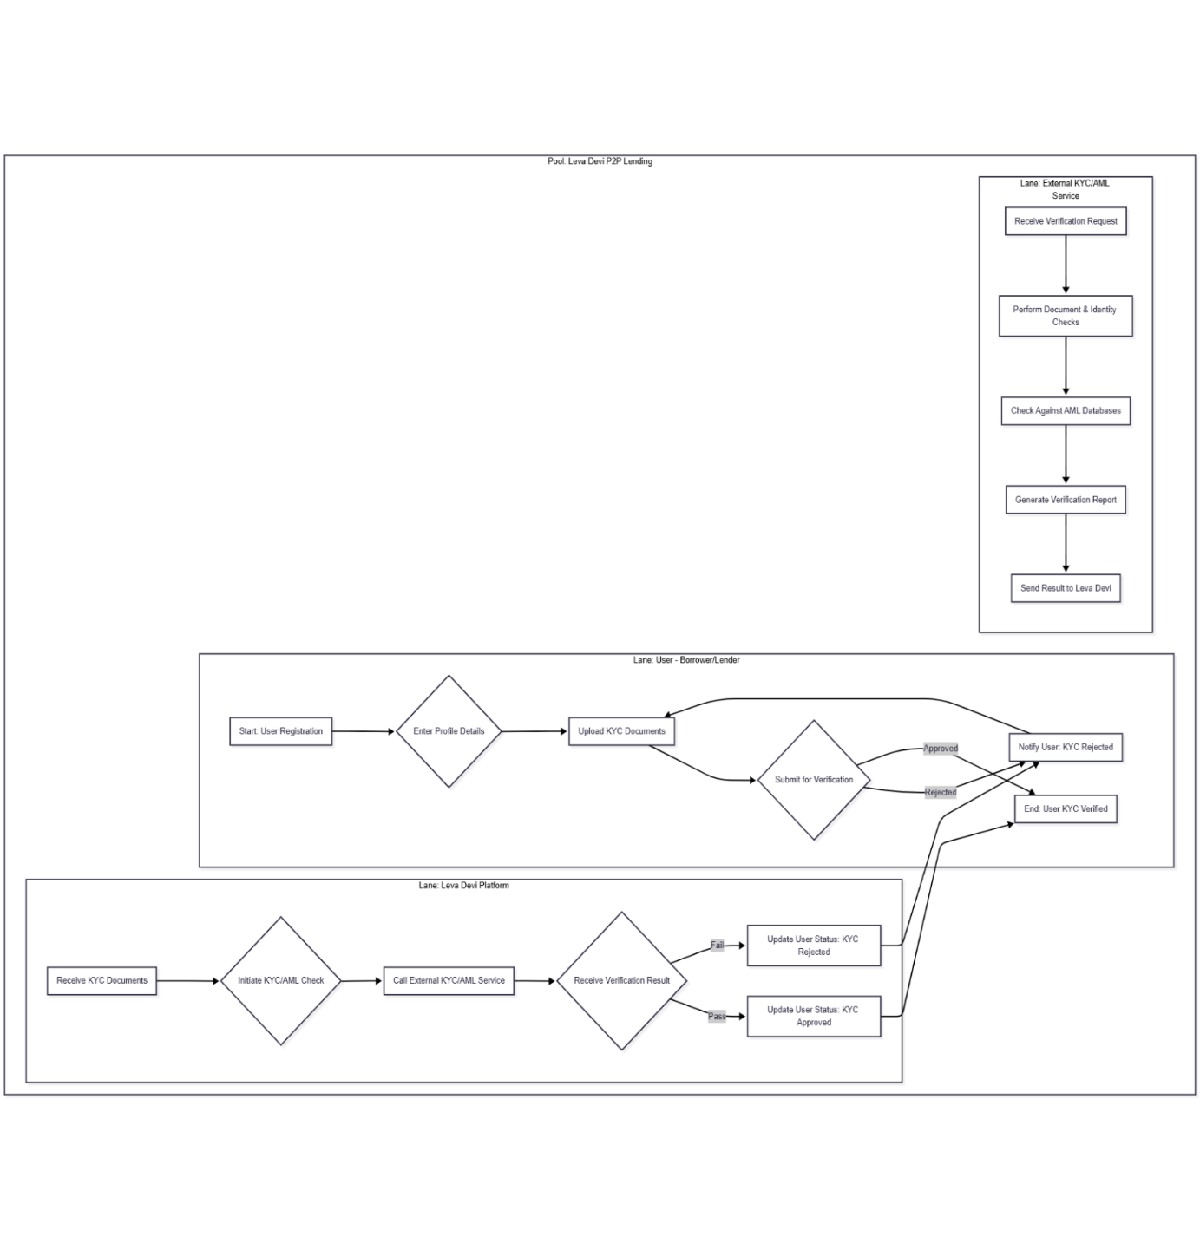
Borrower- Lender KYC Verification Process
3. Approver Requirements (Platform Internal Staff)
- UR-A-001: Secure Internal Access: Securely log in to an internal administration panel with role-based access controls.
- UR-A-002: KYC Document Review Workflow: Access a queue of submitted KYC documents (for both borrowers and lenders) awaiting manual review and be able to efficiently navigate through them.
- UR-A-003: KYC Approval/Rejection: Approve or reject KYC documents, providing mandatory reasons for rejection.
- UR-A-004: Loan Application Review Workflow: Access a queue of borrower loan applications requiring approval, including all submitted data, credit bureau reports, and system-generated AI risk assessments.
- UR-A-005: Loan Application Approval/Rejection: Approve or reject loan applications, with the option to manually adjust system-proposed interest rates or terms (within predefined limits) and document reasons for such adjustments.
- UR-A-006: Payment Holiday Decision: Review borrower requests for payment holidays, including lender approval status, and make a final decision, documenting the rationale.
- UR-A-007: User Profile Inquiry: Access detailed profiles of any borrower or lender, including their history, for investigation or support.
- UR-A-008: Audit Trail of Actions: Have all my approval/rejection actions and changes timestamped and logged for auditing and compliance purposes.
4. Management Requirements (Platform Internal Staff)
- UR-M-001: Secure Internal Access: Securely log in to a comprehensive management dashboard with appropriate access controls.
- UR-M-002: Real-time Performance Dashboards: View aggregated, real-time dashboards displaying key business metrics (e.g., total loans disbursed, number of active users, average loan size, default rates, collection efficiency, revenue figures).
- UR-M-003: Regulatory Reporting Generation: Be able to generate various reports required by the RBI (e.g., periodic returns, loan book details, risk exposure reports) in specified formats.
- UR-M-004: Financial Performance Reporting: Generate detailed financial reports, including profit & loss, balance sheets, and cash flow statements, specific to the platform's operations.
- UR-M-005: User Base Analytics: Access analytics on user acquisition, retention, demographics, and behavior patterns for strategic decision-making.
- UR-M-006: System Health Monitoring: Have a high-level overview of the platform's operational health, including uptime, system performance, and critical alerts.
- UR-M-007: Risk & Fraud Monitoring: Monitor overall portfolio risk, identify potential fraud patterns, and track the effectiveness of risk mitigation strategies.
- UR-M-008: Policy & Configuration Management: Be able to define and update global platform policies, interest rate algorithms, fee structures, and transaction limits.
- UR-M-009: Comprehensive Audit Logs: Access detailed, searchable audit logs of all user actions and system events for compliance, security, and troubleshooting.
- UR-M-010: Business Intelligence Tools: Integrate with or access data through Business Intelligence (BI) tools for deeper analytical insights and custom reporting.

Quality Goals
Priority | Quality Attribute | Description
High | Security & Compliance  Protect user data, ensure the integrity of transactions, and comply with RBI guidelines and relevant financial regulations.  - Data Encryption: 100% of data (in transit and at rest) is encrypted using industry-standard protocols (TLS, AES).  - Compliance: Zero major compliance issues with RBI guidelines within the first year of operation.  - Security Incidents: Less than 0.1% of transactions are flagged for potential security issues (e.g., fraud attempts). | Must comply with RBI (NBFC-P2P) and FEMA for lending, KYC, escrow, and data privacy (e.g., PII handling, AML checks).  End-to-End Encryption: Data encrypted at rest (database, storage) and in transit (TLS/SSL).  Robust Authentication & Authorization: Multi-factor authentication (MFA), OAuth2/JWT for API security, granular RBAC.  Vulnerability Management: Regular security audits, penetration testing, static/dynamic code analysis.  Compliance: Adherence to RBI, PCI DSS (if applicable for card processing), and data privacy regulations.  Fraud Detection: Real-time monitoring and anomaly detection.  DDoS Protection & WAF: Protect against common web attacks.  Secure Coding Practices: OWASP Top 10 mitigation.
High | Scalability  The platform should efficiently handle increasing numbers of users, transactions, and data without compromising performance.  - User Growth: Support a minimum of 10,000 new user registrations per month.  - Transaction Volume: Handle at least 50,000 transactions (loan applications, payments) per day.  - Data Storage: Scale to store at least 100 GB of user and transaction data per month. | Horizontal Scaling: Ability to add more instances of services/databases as load increases.  Microservices Architecture: Allows independent scaling of individual components.  Containerization & Orchestration: (e.g., Kubernetes) for efficient resource management and auto-scaling.  Stateless Services: Maximize scalability and resilience.  Managed Cloud Services: Leverage cloud provider's managed databases, messaging queues, etc.
Medium | Interoperability  - Average API documentation rating is 4.5/5, with a peak of 5/5 during high-traffic periods.  - Average integration time per system is 2 weeks, with a peak of 4 weeks during complex integrations.  - Average data exchange volume per day is 1 GB, with a peak of 5 GB during high-traffic periods.  - Average protocol usage per day is 80% HTTP, 15% HTTPS, and 5% FTP, with a peak of 90% HTTP during high-traffic periods. | Integrate with external systems like CIBIL, CRIF, NACH, PAN/Aadhaar services, and international KYC/AML providers.
High | Availability  The platform should be accessible and usable by all users (lenders, borrowers, approvers, management) always, without interruptions.  - Uptime: 99.99% uptime, ensuring the platform is available 24/7/365.  - Downtime: Less than 1 minute of scheduled maintenance downtime per week.  - Error Rate: Less than 1% of requests result in errors (e.g., HTTP 500 errors). | Ensure high availability of core lending functions (loan creation, funding, EMI, wallet) with near-zero downtime.  Redundant infrastructure (multi-AZ/multi-region deployment).  Automated failover mechanisms.  Load balancing across services.  Disaster Recovery (DR) plan with low RTO/RPO.
Medium | Maintainability  Ensure the platform is easy to maintain, update, and fix, with minimal impact on users.  - Mean Time to Repair (MTTR): Less than 2 hours to resolve and deploy fixes for critical issues.  - Mean Time Between Failures (MTBF): At least 1 month between occurrences of the same critical issue.  - Code Quality: Maintain a code quality score of at least 80% (based on metrics like complexity, testing coverage). | The architecture should allow modular changes (e.g., scoring algorithm updates, UI localization) without impacting other components.
High | Ease of Use (User Experience)  Provide an intuitive, user-friendly experience for all users, ensuring they can easily navigate and use the platform's features.  - User Engagement: At least 80% of users report a satisfactory experience (via surveys or feedback forms).  - Time to Complete Tasks: Average time for a user to complete a task (e.g., loan application, payment) is less than 10 minutes.  - Support Requests: Less than 5% of users require support for navigating the platform. | Intuitive UI/UX: Clean, responsive, and easy-to-navigate interfaces for web and mobile.  Cross-Device Compatibility: Responsive design and dedicated mobile apps (if resources permit) for seamless experience on mobiles, tablets, laptops, and desktops.  Optimized Performance: Fast loading times, quick response to user interactions.
High | Performance  Ensure the platform responds quickly to user interactions, providing a seamless experience.  - Response Time: Average response time for any user action is less than 2 seconds.  - Page Load Time: Average page load time is less than 3 seconds.  - API Response Time: Average API response time for third-party integrations is less than 1 second. | Low Latency: Optimized database queries, caching mechanisms (Redis/Memcached).  Asynchronous Processing: For heavy tasks like KYC verification, credit scoring, notifications.  Efficient Resource Utilization: Well-tuned services and infrastructure.
Medium | Portability/Cloud Agnosticism  - 100% of platform components containerized.  - 99% successful deployments.  - At least 80% of services used are managed services.  - Less than 2 weeks to port the platform. | Containerization (Docker): Packaging applications with dependencies.  Orchestration (Kubernetes): Standardized deployment across different clouds.  Infrastructure as Code (IaC): (Terraform/CloudFormation/ARM Templates) for consistent infrastructure provisioning.  Cloud-Agnostic Services: Using open-source technologies or services that have equivalents across major cloud providers.
High | Observability  - Average log volume per day is 10 GB, with a peak of 50 GB during high-traffic periods.  - Average monitoring data points per minute is 1,000, with a peak of 5,000 during high-traffic periods.  - Average response time to alerts is 5 minutes, with a resolution time of 30 minutes.  - Average MTTD for critical issues is 2 minutes, with a peak of 5 minutes during high-traffic periods.  - Average MTTR for critical issues is 15 minutes, with a peak of 30 minutes during high-traffic periods. | Centralized Logging: Aggregating logs from all services (ELK stack/Splunk/CloudWatch Logs).  Distributed Tracing: To follow requests across microservices.  Monitoring & Alerting: Real-time metrics collection (Prometheus/Grafana) with proactive alerts for performance degradation or errors.

Stakeholder
- Stakeholder: Borrower
Role: Loan Applicant
Expectation:
- Borrower registration with Aadhaar, PAN, and bank account details.
- Loan application with amount, purpose, tenure, and document upload.
- Credit scoring integration with CIBIL/CRIF.
- Competitive interest rates, Auto-assignment of interest rates based on risk profile.
- View loan status, EMI schedule, and repayment progress.
- Secure and private handling of personal and financial data
- Option to halt payment (with conditions)
- Stakeholder: Lenders (India & Global)
Role: Retail/institutional investors
Expectation:
- Lender registration with KYC (passport, PAN, bank details for NRO accounts).
- View loan listings with borrower details like credit scores, interest rates, and risk profiles.
- Tools to review applications and express willingness to lend.
- Invest in full or part of the loan with payment via escrow.
- Ability to track investment performance, EMI receipts and loan status
- Withdraw earnings or reinvest in new loans.
- Secure handling of financial transactions
- Stakeholder: Admins
Role: Operational Support
Expectation:
- Admin user onboarding and KYC approval.
- Monitor loan listings and funding status.
- Real-time insights into platform performance (user growth, loan volume, default rates, revenue).
- Generate regulatory compliance reports (RBI/FEMA).
- Monitor repayment and initiate recovery workflows.
- Admin platform settings (fees, interest bands, caps, user roles and policies).
- Tools for verification, approval, escalation, and recovery tracking
- Stakeholder: Trustee/Bank
Role: Escrow management
Expectation:
- Secure fund flow through RBI-approved escrow and trustee processes
- Stakeholder: Regulators (RBI, Auditors)
Role: Compliance
Expectation:
- Strict adherence to all P2P lending regulations (e.g., Fair Practices Code, data residency, capital requirements, grievance redressal, disclosure norms).
- Robust KYC/AML procedures.
- Data privacy and security standards.
- Regular reporting and audits.
- Stakeholder: DevOps & Developers
Role: Platform builders
Expectation:
- Scalable, testable, modular, and compliant codebase for APIs and UI

Architectural Constraints
1. Regulatory and Compliance Constraints
Constraint | Explanation | Consequences
RBI Compliance | The platform's operations must strictly conform to all relevant guidelines issued by the Reserve Bank of India (RBI) for P2P lending platforms, including KYC/AML norms, fund transfer regulations, data security, privacy, and reporting requirements. This is a non-negotiable legal constraint. | - Mandates Microservices Architecture to encapsulate compliance logic (KYC, payments).  - Requires Event-Driven Architecture (EDA) for an immutable audit trail of transactions and state changes.  -API Gateway is critical for centralizing security controls and ensuring authentication/authorization.  - Polyglot Persistence (PostgreSQL for core data) ensures ACID compliance for financial records.  - Strong Security Patterns (Encryption, IAM, WAF, network segmentation) are mandatory  - Implies dedicated Reporting Microservice for RBI-mandated reports.
Data Privacy (FEMA) | Must comply with FEMA guidelines for lending and data privacy (e.g., PII handling). | - Stringent data handling procedures are required, affecting data storage, access, and transmission.  - Requires robust encryption for data at rest and in transit.  - Influences choices for secure data storage solutions and access control mechanisms.  - All API interactions must adhere to secure and auditable practices.
Ethical AI | AI models, particularly for credit risk assessment, must be accurate, fair, and explainable. | - Requires selection of AI/ML frameworks that support explainable AI (XAI) capabilities.  - Demands rigorous model validation and bias mitigation strategies.  - Necessitates clear mechanisms to provide insights into why a particular score or metric was generated, crucial for transparency and human approvers.
Auditability | The platform must maintain comprehensive logs and audit trails for all system and user actions to meet regulatory scrutiny. | - Event-Driven Architecture is crucial for creating an immutable log of system events.  - Centralized logging solutions (e.g., ELK stack, CloudWatch Logs) are required for aggregation and analysis.  - All API calls and modifications must be logged for security monitoring and compliance.

2. Technical Constraints
Constraint | Explanation | Consequences
Scalability | The system must be capable of supporting a rapidly growing user base (10,000 new users/month) and increasing transaction load (50,000 transactions/day) effectively with minimal adaptations. | - Microservices Architecture enables horizontal scaling of individual services.  - Containerization (Docker) and orchestration (Kubernetes) are required for automatic scaling, load balancing, and efficient resource management.  - Event-Driven Architecture decouples services, allowing them to process events at their own pace.  - Polyglot Persistence (NoSQL for high-volume data) is used for databases designed for horizontal scaling.  - Stateless API microservices and caching mechanisms (Redis) are vital for handling high transaction volumes.
High Availability | The platform must guarantee uninterrupted access round the clock (24/7) with 99.99% uptime for core functions and near-zero downtime. | - Requires Multi-AZ deployment with redundancy for all components (compute, storage, network).  - Automated failover mechanisms are essential (Kubernetes self-healing, DB replication).  - Load balancing across services is mandatory.  - Microservices architecture provides fault isolation.  - A robust Disaster Recovery (DR) plan with low RTO/RPO must be established for API infrastructure.
Security | All online payments must follow Central Bank/Bank Regulator (RBI) guidelines, providing full safety and privacy for users. Transactions should have less than 0.1% flagged for potential security issues. | - API Gateway enforces centralized authentication (OAuth 2.0, JWT), authorization (RBAC), and rate limiting.  - Zero Trust Network with mTLS for microservices communication.  - End-to-end data encryption (at rest and in transit) for all sensitive data.  - Dedicated Security Microservice/WAF for fraud detection, input validation, and protection against web vulnerabilities.  - Regular security audits and penetration testing of APIs are required.
Flexibility / Multi-Cloud Readiness | The platform must support easy transitions across various cloud service providers, aiming for 100% containerization and 99% successful deployments across different clouds. | - Containerization (Docker) and orchestration (Kubernetes) are fundamental for portable deployment units.  - Infrastructure as Code (IaC) is critical for consistent infrastructure provisioning.  - Prioritizing cloud-agnostic managed services that align with open standards (e.g., managed PostgreSQL, Kafka-compatible message queues).  - API-First Design ensures clear contracts between services, simplifying refactoring or swapping out underlying API implementations.
Device Accessibility | The system should be easily accessible on different devices such as mobiles, tablets, laptops, and desktops, ensuring an intuitive, user-friendly experience across multiple devices. | - Responsive Web Design and Native/Hybrid Mobile Apps are required, necessitating a clear separation of frontend (UI) from backend (API).  - The API Gateway provides a unified access point for multiple client applications.  - UI/UX design and API optimization for quick response times are essential for ease of use.
Performance / Responsiveness | The overall experience must be optimized for quick response times (<2 seconds for user actions, <1 second for third-party API integrations), ensuring seamless interaction for users. | - Microservices architecture allows independent optimization of performance-critical services/APIs.  - Caching layers (e.g., Redis) for frequently accessed data reduce database load and improve API response times.  - Event-Driven Architecture offloads long-running tasks to background processing, allowing immediate responses to user requests for user-facing APIs.  - Optimized database queries and efficient resource utilization are crucial.
Integration with Financial Institutions | The platform must provide APIs for financial institutions (e.g., banks, NBFCs) to enable smooth integration for business partnerships (escrow, trustee models, KYC, AML, credit checks, payment processing). | - Requires an API-First Design approach with a well-defined, secure, and versioned set of APIs exposed via an API Gateway.  - Specific microservices need to be designed for external integration to provide partner-specific data or functionalities.  - Extensive integration with external KYC and Credit Bureau APIs is necessary.  - Robust payment gateway and banking APIs (UPI, IMPS, NEFT/RTGS, NACH) are critical for fund disbursement and repayments.
AI/ML Integration | An appropriate AI-based algorithm is required for credit risk assessment for borrowers, and a similar AI-based algorithm for lender metrics. | - Dedicated AI/ML Microservices must encapsulate AI logic, exposing APIs for model inference.  - Event-Driven Architecture can trigger AI model inference asynchronously, ensuring scalability and responsiveness.  - Python with industry-standard AI/ML libraries will be leveraged for development.
Observability | High observability is required with centralized logging, distributed tracing, and real-time monitoring and alerting. | - Centralized Logging (ELK stack, CloudWatch Logs) aggregates all system and API logs.  - Distributed Tracing tools are necessary to follow requests across microservices and their internal APIs.  - Monitoring & Alerting (Prometheus/Grafana) provides real-time dashboards and proactive alerts for performance and errors in API interactions.

3. Organizational and Process Constraints (Implied by Solution Strategy)
Constraint | Explanation | Consequences
Agile Development | Adoption of Agile methodologies (Scrum/Kanban) for iterative and incremental development with continuous feedback loops. | - Requires short development cycles and frequent releases.  - Emphasizes adaptive planning over extensive upfront documentation, though architectural documentation (like arc42) is maintained.  - Impacts team structure (cross-functional teams) and development processes (CI/CD).
CI/CD Pipelines | Implementation of fully automated Continuous Integration and Continuous Deployment pipelines for fast, reliable, and frequent releases. | - Automates the testing and deployment of microservices and their APIs.  - Requires robust version control and automated testing frameworks.  - Ensures consistent and rapid delivery of new features and bug fixes.
Strategic Outsourcing | Delegation of specific, non-core but critical functions to specialized third-party service providers via APIs (KYC, credit bureaus, payment gateways). | - Reduces internal development time and operational burden for these functions.  - Introduces dependency on third-party APIs and their SLAs, security, and reliability.  - Requires robust API integration design and error handling strategies for external interactions.
DevSecOps | Integration of security and compliance practices into every stage of the CI/CD pipeline and daily operations. | - Security and compliance checks become an automated part of the development and deployment process.  - Requires collaboration between development, operations, and security teams.  - Ensures proactive identification and mitigation of vulnerabilities, particularly in APIs and data handling.
API-First Design | All new functionalities and integrations will be designed with an API-first mindset, defining the API contract before or in parallel with implementation. | - Ensures consistency and clear external/internal interfaces for all services.  - Promotes parallel development of frontend and backend teams.  - Requires comprehensive API documentation (OpenAPI/Swagger) and a developer portal.  - Facilitates better planning for API versioning and error handling standards.

Context and Scope

Business Context

The Peer-to-Peer (P2P) Lending Platform serves as a central hub connecting various entities. These partners can be broadly categorized into Human Users and External IT Systems.
I. Human Users
These are the direct individuals interacting with the platform's user interfaces (web, mobile).
- Lender
  - Role: An individual or entity willing to provide funds to borrowers.
  - Domain-Specific Inputs:
    - Registration Data: Personal/entity details (name, contact, address), financial information (bank account for transactions).
    - KYC Documents: Aadhar, PAN, bank statements, proofs of address, and potentially source of funds verification.
    - Lending Preferences: Investment amount, preferred risk profiles (credit scores of borrowers), interest rate expectations, loan tenures.
    - Offer Acceptance: Acceptance of specific borrower loan applications.
  - Domain-Specific Outputs:
    - Platform Metric: An AI-generated metric providing insights into their lending performance or risk exposure.
    - Borrower Applications: Details of loan applications seeking funding, including credit risk, interest rates, and loan purpose.
    - Loan Status: Real-time updates on funded loans, including repayment schedules and principal/interest received.
    - Account Statements: Transaction history, earnings, and current portfolio value.
  - Interfaces: Web Portal (Browser-based UI), Mobile Application (iOS/Android UI).
- Borrower
  - Role: An individual or business seeking funds from lenders.
  - Domain-Specific Inputs:
    - Registration Data: Personal/business details (name, contact, address), financial history, employment/business details.
    - KYC Documents: Aadhar, PAN, bank statements, salary slips/business financial statements, proofs of address.
    - Loan Application Details: Desired loan amount, purpose of loan, preferred tenure.
    - Loan Offer Acceptance: Selection and acceptance of a specific loan offer from lenders.
    - EMI Payments: Periodic (usually monthly) principal and interest payments.
    - Payment Holiday Request: Request to temporarily pause EMI payments (subject to lender/platform approval).
  - Domain-Specific Outputs:
    - Credit Risk & Interest Rate: Platform's assessment of their creditworthiness and the assigned interest rate.
    - Lender Options: Multiple loan offers from various lenders based on their application.
    - Loan Status: Real-time updates on application status, disbursement, and repayment schedule.
    - Payment History: Records of past EMI payments and outstanding balance.
    - Platform Credit Score Impact: Notification or display of how actions (like payment holidays) affect their internal credit score.
  - Interfaces: Web Portal (Browser-based UI), Mobile Application (iOS/Android UI).
- Approver (Platform Internal Role)
  - Role: Members of the P2P platform team responsible for reviewing and approving loan applications and KYC documents.
  - Domain-Specific Inputs:
    - Borrower Applications: Full details of loan applications, including submitted documents, system-generated credit scores, and proposed interest rates.
    - KYC Documents: Uploaded identity and address proofs, financial statements for verification.
    - Policy Exceptions: Requests for deviations from standard policies.
  - Domain-Specific Outputs:
    - Approval/Rejection Status: Decision on the loan application or KYC verification.
    - Assigned Parameters: Finalized credit risk rating, interest rate, and loan terms.
    - Audit Logs: Records of review actions and decisions.
  - Interfaces: Internal Admin Panel (Web-based UI, potentially with workflow tools).
- Management (Platform Internal Role)
  - Role: Leadership and operational teams overseeing the platform's performance, compliance, and strategic direction.
  - Domain-Specific Inputs:
    - Performance Reports: Aggregated data on loan origination, repayment rates, default rates, user growth, revenue.
    - System Health Metrics: Uptime, response times, error rates.
    - Compliance Reports: Data necessary for regulatory filings (e.g., with RBI).
  - Domain-Specific Outputs:
    - Business Intelligence Dashboards: Visualizations of key performance indicators (KPIs).
    - Operational Controls: Configuration of platform rules, user limits, interest rate policies.
    - User Analytics: Insights into user behavior, acquisition, and retention.
  - Interfaces: Internal Management Dashboard (Web-based UI), Business Intelligence Tools, Reporting Tools.
Interacting via APIs
  - Lender/Borrower: Interact with the platform via Web Portal (Browser-based UI) and Mobile Application (iOS/Android UI). These UIs consume the platform's public APIs for registration, KYC, loan applications, fund management, and tracking.
  - Approver/Management: Interact with the platform via Internal Admin Panel (Web-based UI) and Internal Management Dashboard (Web-based UI, BI Tools). These internal UIs consume administrative and reporting APIs.
II. External IT Systems
These are third-party services or regulatory bodies that the P2P platform interacts with programmatically or through compliance.
- RBI (Reserve Bank of India)
  - Role: The primary regulatory body governing P2P lending in India.
  - Interaction: Not a direct IT system integration for transactional data flow, but the platform's architecture, processes, and data handling must be compliant with RBI guidelines (e.g., Master Direction on NBFC-P2P Lending Platform, KYC norms, operational transparency, data retention). This implies regular reporting and adherence to prescribed norms.
  - Domain-Specific Formats/Protocols: Compliance reports may need to be submitted in specific formats (e.g., electronic filings, audit reports).
- KYC Verification Services
  - Role: Third-party APIs for automated identity and address verification using national databases (e.g., Aadhaar, PAN, Voter ID).
  - Inputs (to Service): Borrower/Lender personal details (Name, Date of Birth, ID number), scanned document images or XML data.
  - Outputs (from Service): Verification status (Success/Fail), authenticity score, parsed data from documents.
  - Interfaces: RESTful APIs (JSON/XML).
  - Communication Protocol: HTTPS (secure encrypted communication).
  - Domain-Specific Formats: Aadhar e-KYC XML, PAN verification API specifications.
- Credit Bureaus (e.g., CIBIL, Experian, Equifax, CRIF High Mark in India)
  - Role: Providers of credit scores and detailed credit reports for individuals and businesses, crucial for the AI-based credit risk assessment.
  - Inputs (to Bureau API): Borrower's identifying information (Name, PAN, Date of Birth, Address).
  - Outputs (from Bureau API): Credit Score, detailed credit report (historical loan data, defaults, inquiries, repayment behavior).
  - Interfaces: APIs (often SOAP-based, increasingly RESTful).
  - Communication Protocol: HTTPS.
  - Domain-Specific Formats: Bureau-specific data structures for credit reports (e.g., CIR - Credit Information Report format).
- Payment Gateways / Banks (for fund transfers and EMI collections)
  - Role: Facilitate the movement of funds between lenders, borrowers, and the platform (for fees), and manage EMI collections.
  - Inputs (to Gateway API): Transaction amount, source/destination bank account details (tokenized), transaction type (disbursement, repayment, fee), unique transaction ID.
  - Outputs (from Gateway API): Transaction status (Success/Failure/Pending), transaction ID, settlement details, payment confirmation receipts.
  - Interfaces: APIs (e.g., NPCI's UPI, IMPS, NEFT/RTGS gateway integrations, NACH mandate services for EMIs).
  - Communication Protocol: HTTPS.
  - Domain-Specific Formats: ISO 20022 for financial messaging, NACH mandate files for bulk debit/credit, UPI QR codes/payment links.
- Financial Institutions (for potential partnerships)
  - Role: Banks, Non-Banking Financial Companies (NBFCs), or other financial entities looking to integrate with the P2P platform for various services (e.g., referral programs, white-label solutions, data sharing with consent).
  - Inputs (to Platform API): Partner-specific data, authenticated requests for user information (with user consent), payment instructions, new loan application referrals.
  - Outputs (from Platform API): Loan status, user profiles, transaction history, analytical data, API tokens.
  - Interfaces: Well-documented RESTful APIs.
  - Communication Protocol: HTTPS.
  - Domain-Specific Formats: JSON for data exchange, potentially Open Banking standards if applicable in India's context.
- Cloud Service Providers (e.g., AWS, Azure, GCP)
  - Role: Provide the underlying infrastructure, compute, storage, and managed services for deploying and operating the platform.
  - Interaction: The platform components are deployed on the CSP's infrastructure. While not a direct "business" communication partner in the transaction flow, they are critical IT systems providing the foundation.
  - Inputs (to CSP): Deployment configurations (Infrastructure as Code), application code, data.
  - Outputs (from CSP): Logs, metrics, service availability reports, billing information.
  - Interfaces: Cloud APIs, SDKs, management consoles.
  - Communication Protocol: HTTPS, various proprietary protocols for internal cloud services.
Here's a visual representation of these communication partners and their interactions:
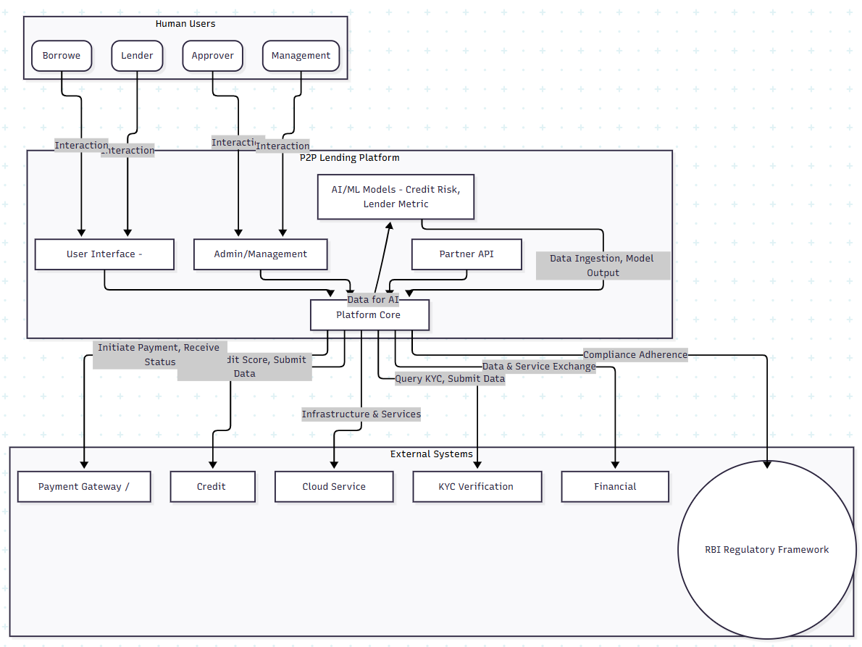

Technical context

The P2P lending platform will interact with various external entities and internal components through a set of well-defined interfaces. The primary channels will be web-based and API-driven, leveraging secure transmission media.
1. User-Facing Interfaces (Client Applications)
These are the primary channels through which Lenders, Borrowers, Approvers, and Management interact with the platform.
- Channels:
  - Web Application (Browser): A responsive web portal accessible via standard web browsers (Chrome, Firefox, Safari, Edge).
  - Mobile Applications (iOS/Android): Native mobile apps providing an optimized user experience.
  - Admin/Management Dashboard: A dedicated web application for internal Approvers and Management.
- Transmission Media:
  - HTTPS (HTTP Secure): All communication will be encrypted using TLS/SSL to ensure data privacy and integrity. This is crucial for handling sensitive financial and personal data as per RBI guidelines.
- Domain-Specific Input/Output Mapping:
  - Borrower Input:
    - Self-registration details (name, email, phone, basic profile).
    - KYC documents upload (scans/photos of Aadhaar, PAN, bank statements, address proof).
    - Loan application details (amount, purpose, desired term, financial information).
    - Acceptance of loan offers.
    - Requests for "payment stop" for a month.
    - Tracking loan status, repayment schedules.
  - Borrower Output:
    - Registration confirmation, KYC approval status.
    - Credit risk assessment assigned interest rate.
    - Available loan offers from lenders.
    - Loan disbursement confirmation, repayment reminders.
    - Real-time loan status, EMI schedules, payment history.
  - Lender Input:
    - Self-registration details (name, email, phone, basic profile).
    - KYC documents upload (as per regulations for financial investors).
    - Funds deposit instructions.
    - Reviewing loan applications/borrower profiles.
    - Expressing willingness to lend (offering funds).
    - Tracking investment portfolio, repayment status.
  - Lender Output:
    - Registration confirmation, KYC approval status.
    - Browseable list of loan applications with associated risk profiles and interest rates.
    - Investment portfolio summary, earnings reports.
    - Real-time repayment status, fund withdrawal options.
  - Approver Input (Internal Dashboard):
    - Review of borrower KYC documents and applications.
    - Manual override/approval for credit risk assessment (if applicable).
    - Monitoring overall platform activities.
  - Approver Output (Internal Dashboard):
    - Approval/rejection status of KYC and loan applications.
    - Detailed borrower profiles and risk analysis.
  - Management Input (Internal Dashboard):
    - Performance metrics configuration (e.g., success criteria).
    - User management, system configurations.
  - Management Output (Internal Dashboard):
    - Real-time dashboards of platform performance (loan origination, disbursement, repayment rates, defaults, user growth).
    - Financial reports, audit logs.
2. Backend and External System Integration Interfaces
These interfaces facilitate data exchange and service calls with third-party providers and internal microservices.
- Channels:
  - RESTful APIs (via API Gateway): The primary communication channel for most external and internal service-to-service interactions. An API Gateway will manage security, rate limiting, and routing.
  - Message Queues (e.g., Apache Kafka, RabbitMQ, AWS SQS/Azure Service Bus): For asynchronous processing of events, enabling loose coupling and scalability (e.g., KYC processing, credit scoring, notifications).
  - Database Connections (Internal): Secure, direct connections between application services and the database layer.
  - Webhooks: For receiving real-time notifications from external services (e.g., payment gateway callbacks).
  - SFTP/Secure File Transfer: For bulk data exchange, though less preferred than APIs for real-time operations (e.g., potentially for regulatory reports if API is not available, or large data exports).
- Transmission Media:
  - HTTPS (HTTP Secure) / TLS: For all API calls, ensuring end-to-end encryption.
  - TCP/IP (with SSL/TLS): For secure connections to message queues and databases.
  - Proprietary Protocols: For specific database connections (e.g., PostgreSQL protocol over TLS).
  - SSH/SFTP: For secure file transfers.
- Domain-Specific Input/Output Mapping:
  - KYC & Identity Verification Services (e.g., Aadhaar e-KYC API, DigiLocker, PAN verification, bank account verification):
    - Input (Platform to Service): Borrower's Aadhaar/PAN number, demographic details, bank account number.
    - Output (Service to Platform): Verification status, demographic data from Aadhaar, PAN details, bank account validation.
    - Channel: RESTful API via HTTPS.
  - Credit Bureaus (e.g., CIBIL, Experian, Equifax India):
    - Input (Platform to Service): Borrower's personal details, PAN, loan inquiry request.
    - Output (Service to Platform): Comprehensive credit report, credit score.
    - Channel: RESTful API via HTTPS.
  - AI/ML Credit Risk & Lender Metric Algorithms (Internal Microservices):
    - Input (Platform to AI/ML Service): Borrower financial history, credit bureau data, application details, market data (for lender metrics).
    - Output (AI/ML Service to Platform): Credit risk score/grade, recommended interest rate, personalized lender metric (e.g., expected return, risk appetite match).
    - Channel: Internal RESTful APIs (via internal service mesh or direct calls) or Message Queues for asynchronous processing.
  - Payment Gateways & Banking Partners (e.g., UPI, Net Banking, Card Processors):
    - Input (Platform to Payment Gateway): Loan disbursement requests, EMI collection requests, lender fund deposit/withdrawal requests, transaction amounts, beneficiary details.
    - Output (Payment Gateway to Platform): Transaction status (success/failure), payment confirmations, settlement reports.
    - Channel: RESTful APIs via HTTPS, Webhooks for status updates. Adherence to RBI's payment system guidelines (e.g., UPI specifications, secure payment handling).
  - SMS & Email Notification Gateways:
    - Input (Platform to Gateway): Recipient phone number/email, message content (e.g., loan approval, repayment reminder, OTP).
    - Output (Gateway to Platform): Delivery status reports.
    - Channel: RESTful APIs via HTTPS (for modern gateways), or SMTP for email, SMPP for SMS.
  - Regulatory Reporting (RBI):
    - Input (Platform to Reporting System/Portal): Aggregated loan data, borrower demographics, default rates, transaction volumes, financial health metrics, as specified by RBI reporting formats.
    - Output (Reporting System/Portal): Confirmation of submission, compliance reports.
    - Channel: Potentially secure Web-based Portals (manual upload), SFTP for structured data files (CSV, XML), or dedicated APIs provided by RBI/regulated entities (if available). This will strictly adhere to RBI guidelines on data format and submission frequency.
  - APIs for Financial Institutions (Business Partnerships):
    - Input (FI to Platform): Partner-specific queries (e.g., anonymized portfolio insights, potential borrower leads based on criteria).
    - Output (Platform to FI): Structured data responses, analytical insights.
    - Channel: Dedicated, versioned RESTful APIs with robust authentication (e.g., OAuth 2.0) and authorization mechanisms, all over HTTPS.
3. Internal System Interfaces (Microservices Communication)
Within the platform, various microservices will communicate with each other.
- Channels:
  - Internal RESTful APIs / gRPC: For synchronous service-to-service communication.
  - Message Queues: For asynchronous event-driven communication and long-running tasks (e.g., triggering notifications after loan approval, processing credit checks in the background).
  - Service Mesh (e.g., Istio, Linkerd): For managing internal service communication, traffic management, and observability.
- Transmission Media:
  - TCP/IP (often within a Virtual Private Cloud/Network): Direct communication between services, potentially secured with mTLS (mutual TLS) for enhanced internal security.
Visual Representation of Key Interfaces
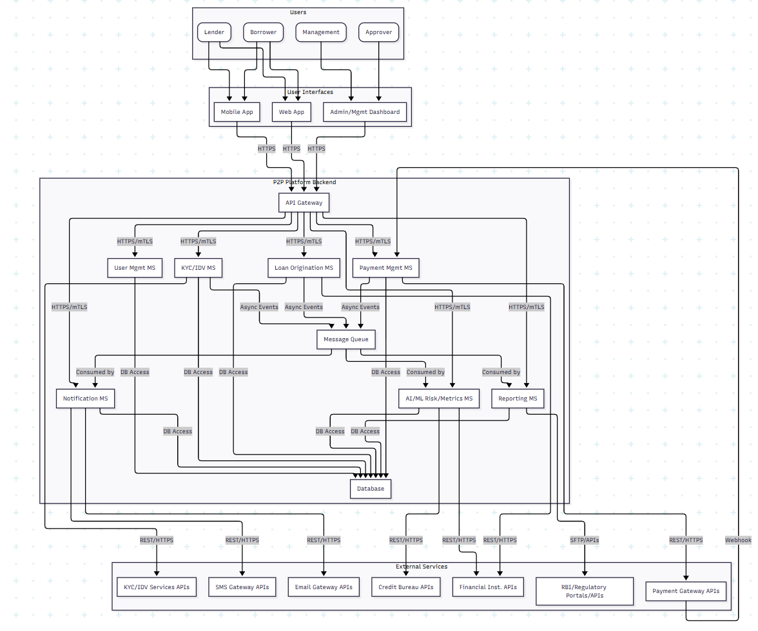

Solution Strategy

Technology Decisions
Decision Area | Decision & Explanation | Motivation (Problem Statement, Quality Goals, Constraints)
Cloud-Native First & Multi-Cloud Readiness | The platform will be primarily deployed on a leading public cloud provider (e.g., AWS, Azure, or GCP), leveraging its managed services (compute, database, messaging, AI/ML platforms). Multi-cloud flexibility will be achieved through containerization and open-standard services, rather than provider-specific APIs at the outset. | HA, Scalability, Flexibility: Cloud-native services offer unparalleled scalability, high availability, and significantly accelerate development by offloading infrastructure management. Containerization provides the necessary abstraction for future multi-cloud transition.
Containerization with Kubernetes | All application services will be packaged as Docker containers and orchestrated using Kubernetes (or a managed Kubernetes service like EKS, AKS, GKE). | Scalability, HA, Flexibility, Development Velocity: Kubernetes provides automated scaling, self-healing capabilities, and efficient resource utilization, directly addressing HA and scalability. It also enables consistent deployment environments across development, testing, and production, speeding up delivery and supporting the multi-cloud strategy.
Polyglot Persistence | A hybrid approach to data storage will be employed:  PostgreSQL (Managed Relational DB): For core transactional data (users, loans, payments) requiring strong consistency (ACID).  NoSQL Database (e.g., DynamoDB/Cosmos DB): For high-volume, flexible data like audit logs, real-time analytics, or unstructured document metadata (e.g., KYC files). | Performance, Scalability, Data Integrity: Different data types have different access patterns and consistency requirements. PostgreSQL ensures transactional integrity for financial operations (RBI compliance), while NoSQL databases provide high performance and scalability for other data, optimizing overall system efficiency.
AI/ML Frameworks | Leverage Python with industry-standard AI/ML libraries (e.g., TensorFlow, PyTorch, scikit-learn) for developing credit risk models and lender metrics. These models will be deployed as dedicated microservices or serverless functions. | Functional Requirement (AI), Scalability, Rapid Dev: Directly fulfills the requirement for AI-based algorithms. Python's ecosystem offers mature tools and a vast community, accelerating development and deployment of robust, scalable ML models.
Modern Programming Languages & Frameworks | Backend services primarily in Java (Spring Boot) or Python (Django/Flask) for their robustness, performance, and extensive ecosystems. Frontend developed with modern JavaScript frameworks (React, Angular, or Vue.js) for web, and native frameworks (Swift/Kotlin) or cross-platform (React Native/Flutter) for mobile. | Ease of Use, Rapid Dev, Performance, Maintainability: These choices enable highly responsive user interfaces across devices (laptops, mobiles, tablets), crucial for ease of use. Their maturity and developer communities support rapid, high-quality development to meet the 6-month deadline and ensure long-term maintainability.

Top-Level Decomposition of the System
Architectural Pattern | Decision & Explanation | Motivation (Problem Statement, Quality Goals, Constraints)
Microservices Architecture | The system will be decomposed into small, independent, and loosely coupled services, each responsible for a specific business capability (e.g., User Management, KYC/IDV, Loan Origination, Credit Risk Engine, Payment Processing, Notification, Reporting). An API Gateway will act as the single entry point for all client applications and external integrations. | Scalability, High Availability, Agility, Rapid Launch: Allows independent development, deployment, and scaling of components, which is critical for the 6-month launch and ensures the system can handle increasing user load effectively. Isolation of services limits the blast radius of failures, improving HA.
Event-Driven Architecture (EDA) with Message Queues | Services will communicate asynchronously using a message broker (e.g., Apache Kafka, AWS SQS/SNS, Azure Service Bus). Key business events (e.g., LoanApplicationSubmitted, KYCApproved, PaymentProcessed) will be published to the message queue, triggering reactions from other interested services. | Loose Coupling, Responsiveness, Scalability, Auditing: Decouples services, making the system more resilient and easier to extend. Enables immediate feedback to users while complex processing occurs in the background. Handles high volumes of events, contributing to scalability, and provides an immutable log for audit and compliance (RBI).

Decisions on How to Achieve Key Quality Goals
Quality Goal | Scenario | Solution Approach
High Availability | Users expect uninterrupted access (24/7) and transactions without halt. | - Multi-AZ Deployment: Deploy microservices and data stores across multiple Availability Zones within the chosen cloud region.  Redundancy & Failover: Utilize load balancers, auto-scaling groups for compute, and database replication (primary-replica with automated failover).  Circuit Breakers & Retries: Implement resilience patterns in inter-service communication.
Scalability | System must support increasing users and transactions effectively with minimal adaptations. | - Horizontal Scaling: Design stateless microservices to scale horizontally (add more instances) using Kubernetes Horizontal Pod Autoscaler.  Managed Services: Leverage cloud-managed services (databases, message queues, serverless functions) that scale automatically. Caching: Implement caching strategies (e.g., Redis) for frequently accessed immutable data.
Security | All online payments must follow RBI guidelines; full safety and privacy for users. | - Zero Trust Architecture: Implement strong authentication (MFA), fine-grained authorization (Role-Based Access Control - RBAC) for all users and services.  Encryption: End-to-end encryption (TLS/SSL) for data in transit; encryption at rest for all sensitive data.  Network Segmentation: Isolate services and data layers using Virtual Private Cloud (VPC) and network security groups/firewalls.  WAF & DDoS Protection: Protect against common web exploits and volumetric attacks.  Regular Audits: Conduct penetration testing, vulnerability assessments, and adhere strictly to RBI cyber security framework.
Ease of Use | Easily accessible on different devices (mobile, tablet, laptop, desktop); quick response times. | - Responsive UI/UX: Develop a modern, intuitive, and responsive user interface for both web and mobile platforms using popular frontend frameworks.  API-First Design: Ensure APIs are well-documented and optimized for quick response times, powering efficient client-side interactions.  Consistent Design Language: Maintain a unified experience across all touchpoints.
Rapid Time-to-Market | Platform launch early | - Agile Development: Employ Scrum or Kanban for iterative development, frequent feedback, and adaptive planning.  CI/CD Pipelines: Implement fully automated Continuous Integration and Continuous Deployment pipelines for fast, reliable, and frequent releases.  Managed Cloud Services: Prioritize using cloud-managed services to reduce operational overhead and accelerate deployment of infrastructure.
RBI Compliance | Meet guidelines published by RBI. | - Compliance by Design: Embed RBI's KYC, AML, data localization, transaction limits, and reporting requirements into core architecture and business logic from inception.  Audit Trails & Logging: Implement comprehensive, immutable logging for all transactions and user actions.  Secure Data Handling: Strict adherence to data privacy and protection norms outlined by RBI for financial data.  Dedicated Reporting Microservice: For generating necessary regulatory reports in specified formats.

Relevant Organizational Decisions
Organizational Aspect | Decision & Explanation | Motivation (Problem Statement, Quality Goals, Constraints)
Development Process | Agile Methodologies (Scrum/Kanban): Adopt an iterative and incremental development approach with short sprints/iterations, continuous feedback loops, and frequent releases. | Rapid Launch (6 months), Adaptability: Agile allows for quick adaptation to evolving requirements and market feedback, crucial for a startup in a regulated environment. It prioritizes working software over extensive documentation initially, accelerating time-to-market.
Team Structure | Cross-Functional Product Teams (aligned with Microservices): Form small (e.g., 5-9 people), self-organizing teams, each responsible for the full lifecycle (development, testing, deployment, operations) of one or more microservices/business capabilities (e.g., "Loan Origination Team," "Payment Team"). | Agility, Ownership, Quality: Fosters strong ownership, reduces inter-team dependencies, and enhances decision-making speed. This structure perfectly aligns with the microservices architecture, maximizing throughput and quality.
Delegation to Third Parties | Strategic Out-sourcing for Non-Core Capabilities: Delegate specific, non-core but critical functions to specialized third-party service providers via APIs. This includes:  KYC & Identity Verification: APIs for Aadhaar, PAN, bank account verification.  Credit Bureaus: APIs for fetching credit scores and reports.  Payment Gateways & Banking Integrations: For fund transfers, EMI collections.  SMS & Email Notification Services. | Rapid Launch, Focus on Core Business, Expertise, Compliance: Leveraging external specialists significantly reduces development time and operational burden for non-differentiating features. It ensures compliance with specific regulatory requirements (e.g., payment processing security, credit reporting standards) by relying on proven, certified providers. This allows the core team to focus on the unique P2P lending logic and AI.
Security & Compliance Integration | Embedded DevSecOps & Dedicated Compliance Officer: Integrate security and compliance practices into every stage of the CI/CD pipeline and daily operations (DevSecOps). Appoint a dedicated Compliance Officer/Team from day one to continuously monitor and ensure adherence to RBI regulations, data privacy, and ethical lending practices. | Security, RBI Compliance, Risk Mitigation: Proactive and continuous integration of security and regulatory checks minimizes vulnerabilities and ensures legal adherence, which is paramount in the financial sector. This avoids costly reworks post-launch and builds user trust.
Monitoring & Observability | Centralized Logging, Monitoring, and Alerting: Implement a comprehensive system for collecting logs, metrics, and traces across all microservices and infrastructure components. Use tools for real-time dashboards and automated alerts. | High Availability, Scalability, Operations: Essential for quickly identifying and resolving issues, understanding system performance, capacity planning, and demonstrating operational resilience to regulators.

Building Block View
The Building Block View describes the static decomposition of the Leva Devi P2P Lending Platform into smaller, manageable components (building blocks), and illustrates their relationships and dependencies. This view is crucial for understanding the system's structure, facilitating development, and ensuring alignment with architectural constraints like scalability, maintainability, and security.

Whitebox Overall System

This section provides a high-level overview of the entire Leva Devi P2P Lending Platform, depicting its primary internal components and their interactions with external entities.
Here is a System Context Diagram illustrating the overall system:
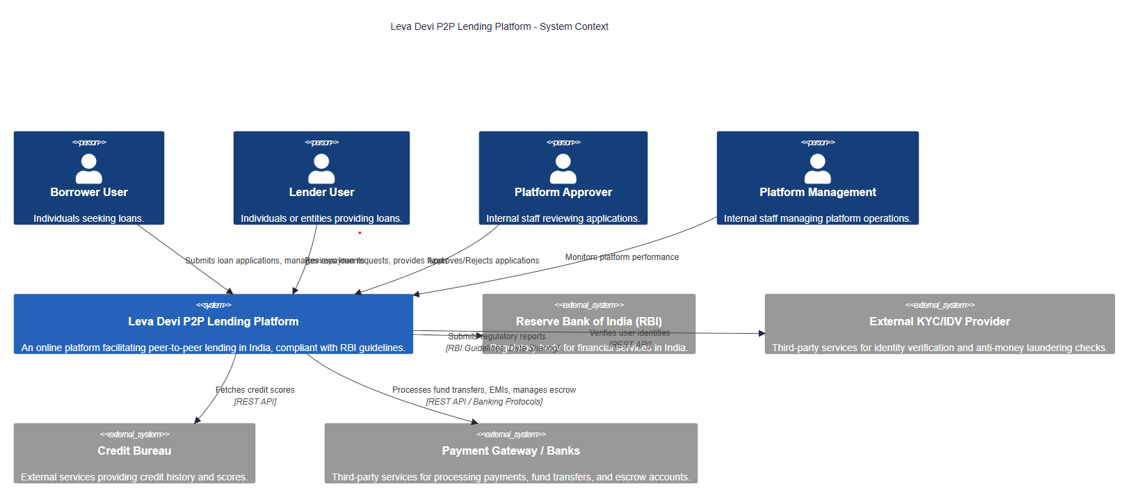
The decomposition of the Leva Devi P2P Lending Platform into a microservices architecture is driven by several key factors, directly addressing the architectural constraints previously identified:
- Scalability: Microservices allow individual services to be scaled independently based on demand, enabling the platform to handle increasing user loads (10,000 new users/month) and transaction volumes (50,000 transactions/day) without monolithic bottlenecks. This is crucial for high growth.
- High Availability & Resilience: Isolating functionalities into separate services means a failure in one service does not bring down the entire system (fault isolation). This supports the 99.99% uptime requirement.
- Flexibility & Multi-Cloud Readiness: Microservices, coupled with containerization (Docker) and orchestration (Kubernetes), promote cloud-agnostic deployments and easier transitions across various cloud providers, fulfilling the 100% containerization goal.
- Maintainability & Agility: Smaller, focused codebases are easier to understand, develop, and deploy. This supports Agile development methodologies and CI/CD pipelines, enabling faster iterations and shorter time-to-market for new features.
- Security & Compliance: Specific services can be hardened and secured according to their data sensitivity and regulatory requirements (e.g., Payment & Escrow Service for RBI compliance). The API Gateway centralizes security controls.
- Technology Heterogeneity (Polyglot Persistence/Programming): Microservices allow teams to choose the best technology stack (database, programming language) for each service's specific needs, which is beneficial for components like the AI/ML service.
- Team Autonomy: Enables smaller, cross-functional teams to own and operate specific services end-to-end, improving development velocity and accountability.
Contained Building Blocks (Black Boxes)
Name | Responsibility | Major Interfaces | Code Location
API Gateway | Single entry point for all client requests; handles routing, authentication, authorization, rate limiting, and response aggregation. | Exposes REST APIs to client applications; forwards requests to internal microservices. | /services/api-gateway
User Management Service | Manages user registration (Borrower, Lender, Approver, Management), login, profiles, roles, and authentication tokens. | POST /register, POST /login, ``GET /users/{id}, PUT /users/{id}` | /services/user-management
KYC/IDV Service | Orchestrates the Know Your Customer (KYC) and Identity Verification (IDV) process; integrates with external KYC providers. | POST /kyc/submit, GET /kyc/status/{id}, POST /kyc/approve | /services/kyc-idv
Loan Origination Service | Manages the lifecycle of loan applications from submission to approval; handles application data, status tracking, and workflow. | POST /loans/apply, GET /loans/{id}, PUT /loans/{id}/status | /services/loan-origination
Credit Risk & AI Service | Calculates credit scores for borrowers and assesses risk based on various data points (e.g., credit bureau data, application data); provides lender metrics using AI/ML algorithms. | POST /credit-risk/assess, GET /credit-risk/score/{borrowerId}, GET /lender-metrics/{lenderId} | /services/credit-risk-ai
Lending Marketplace Service | Facilitates matching between borrowers and lenders; manages loan offers, bids, and acceptance processes. | GET /marketplace/loans, POST /marketplace/offer, POST /marketplace/accept | /services/lending-marketplace
Payment & Escrow Service | Manages all financial transactions including loan disbursements, EMI collections, fund transfers, and interactions with payment gateways and escrow accounts. Ensures RBI compliance for financial operations. | POST /payments/disburse, POST /payments/collect-emi, GET /payments/transactions/{id} | /services/payment-escrow
Notification Service | Sends out notifications to users (email, SMS) for various events (e.g., application status updates, payment reminders, loan offer alerts). | POST /notify/email, POST /notify/sms (internal API, triggered by events) | /services/notification
Reporting & Analytics Service | Generates various reports (regulatory, operational, financial performance, AI model performance); provides dashboards for management and compliance officers. | GET /reports/rbi-compliance, GET /reports/transactions, GET /analytics/dashboard | /services/reporting-analytics
Frontend Applications | User-facing web and mobile applications for Borrowers and Lenders. | Consumes REST APIs exposed by the API Gateway. | /frontend/borrower-app, /frontend/lender-app, etc.
Admin/Approver Portal | Web application for internal Approvers and Management to review applications, manage users, and monitor platform activity. | Consumes REST APIs exposed by the API Gateway (with elevated permissions). | /frontend/admin-portal
Message Broker (Kafka) | Enables asynchronous communication between microservices, facilitating event-driven architecture, decoupling, and resilience. | Publishes and subscribes to topics (e.g., loan_application_submitted, kyc_approved, payment_successful). | Centralized infrastructure component (e.g., Apache Kafka)
Database (PostgreSQL) | Primary relational database for core financial data, user profiles, and critical transactional information requiring strong consistency (ACID properties). | SQL interface; accessed by multiple microservices for their respective data. | Managed Database Service (e.g., AWS RDS PostgreSQL)
NoSQL Database (MongoDB) | Used for semi-structured data, audit logs, or high-volume, less relational data where flexibility and horizontal scalability are prioritized. | NoSQL interface; accessed by specific microservices (e.g., Reporting & Analytics, Audit Log). | Managed Database Service (e.g., AWS DocumentDB / MongoDB Atlas)
Caching Service (Redis) | In-memory data store for accelerating API responses by storing frequently accessed data, reducing database load. | Key-value store interface; accessed by various microservices for caching. | Managed Cache Service (e.g., AWS ElastiCache for Redis)

The following table provides a pragmatic overview of the key building blocks (microservices and core components) within the Leva Devi P2P Lending Platform.
Detailed Black Box Descriptions (Level 1)
Here are more detailed black box descriptions for some of the critical building blocks:
API Gateway
- Purpose/Responsibility:
  - Acts as the single entry point for all client requests (web, mobile, admin).
  - Routes requests to the appropriate microservice based on URL paths.
  - Enforces security policies: authenticates users (e.g., JWT validation), authorizes requests (RBAC), and applies rate limiting to prevent abuse.
  - Handles cross-cutting concerns such as logging, monitoring, and potentially request/response transformation.
  - Provides a unified API contract for external consumers, abstracting the underlying microservice architecture.
- Interface(s):
  - External API: Standard RESTful HTTP/S endpoints (e.g., /api/v1/users, /api/v1/loans).
  - Internal API: Communicates with backend microservices, typically over HTTP/S, often within a private network.
  - Qualities: High performance (low latency), high availability (redundancy), robust security (WAF integration, DDoS protection).
- Quality/Performance Characteristics: Must be highly available (e.g., 99.99% uptime) and capable of handling peak traffic with sub-100ms latency for routing and policy enforcement.
- Directory/File Location: Typically deployed as an independent service in a container orchestration platform (e.g., Kubernetes Ingress/API Gateway such as Envoy, Nginx, or cloud-managed API Gateway like AWS API Gateway).
- Fulfilled Requirements: Security, Scalability, High Availability, Device Accessibility, Performance/Responsiveness.
- Open Issues/Problems/Risks: Potential single point of failure if not properly designed for high availability; can become a bottleneck if not optimized.
User Management Service
- Purpose/Responsibility:
  - Manages the complete lifecycle of all user types (Borrower, Lender, Approver, Management).
  - Handles user registration, login, profile management (viewing, updating).
  - Stores and manages user credentials securely (hashed passwords).
  - Manages user roles and permissions (Role-Based Access Control - RBAC).
  - Integrates with authentication providers (e.g., OAuth 2.0).
- Interface(s):
  - POST /register: Registers a new user.
  - POST /login: Authenticates a user and issues a token.
  - GET /users/{id}: Retrieves user profile details.
  - PUT /users/{id}: Updates user profile.
  - GET /users/{id}/roles: Retrieves user roles.
  - Internal Events: Publishes user_registered, user_profile_updated events to the Message Broker.
  - Qualities: High security for sensitive user data, strong data integrity, high availability.
- Quality/Performance Characteristics: High throughput for registration/login, fast response times for profile lookups. Secure handling of PII.
- Directory/File Location: /services/user-management
- Fulfilled Requirements: Security, RBI Compliance (related to user data handling), Device Accessibility, High Availability.
- Open Issues/Problems/Risks: Secure storage of PII and compliance with data privacy regulations (FEMA, RBI). Potential for unauthorized access if authentication/authorization is weak.
Loan Origination Service
- Purpose/Responsibility:
  - Manages the entire loan application process, from initial submission to final approval/rejection.
  - Stores loan application details (amount, tenure, purpose, personal details).
  - Manages the state transitions of a loan application (e.g., Draft -> Submitted -> Under Review -> Credit Assessed -> Approved/Rejected).
  - Orchestrates calls to other services (e.g., KYC/IDV, Credit Risk & AI) during the application workflow.
- Interface(s):
  - POST /loans/apply: Submits a new loan application.
  - GET /loans/{id}: Retrieves details of a specific loan application.
  - PUT /loans/{id}/status: Updates the status of a loan application (e.g., by Approver).
  - GET /loans/borrower/{borrowerId}: Retrieves all applications for a borrower.
  - Internal Events: Publishes loan_application_submitted, loan_application_status_updated, loan_application_approved events.
  - Qualities: High data integrity, reliable workflow management, auditability of application changes.
- Quality/Performance Characteristics: Must be able to handle a high volume of new applications and complex state transitions reliably.
- Directory/File Location: /services/loan-origination
- Fulfilled Requirements: Functional requirements (loan application), Auditability, Performance/Responsiveness.
- Open Issues/Problems/Risks: Complex workflow management, potential for data inconsistencies if state transitions are not robustly handled.
Credit Risk & AI Service
- Purpose/Responsibility:
  - Houses and executes the AI-based algorithms for credit risk assessment for borrowers.
  - Calculates a credit score or risk rating based on data from various sources (loan application, KYC, Credit Bureau).
  - Provides an appropriate metric/score for lenders based on platform data and AI analysis.
  - Exposes APIs for credit score inference and lender metric generation.
  - Manages AI model deployment, monitoring, and retraining.
- Interface(s):
  - POST /credit-risk/assess: Triggers a credit risk assessment for a borrower.
  - GET /credit-risk/score/{borrowerId}: Retrieves the latest credit score for a borrower.
  - GET /lender-metrics/{lenderId}: Provides performance metrics or insights for a lender.
  - Internal Events: Consumes loan_application_submitted, kyc_approved events; publishes credit_score_calculated events.
  - Qualities: Accuracy, fairness (Ethical AI), explainability (XAI), low latency for assessment (though can be asynchronous).
- Quality/Performance Characteristics: Model accuracy, low inference latency, capability to handle large datasets for training, robustness against data drift. Explainability is a key non-functional requirement.
- Directory/File Location: /services/credit-risk-ai (likely Python-based)
- Fulfilled Requirements: AI/ML Integration, Ethical AI, Performance/Responsiveness.
- Open Issues/Problems/Risks: Model bias, data quality issues, regulatory scrutiny of AI decisions, need for continuous model monitoring and retraining.
Payment & Escrow Service
- Purpose/Responsibility:
  - Manages all fund-related transactions: loan disbursements, EMI collections, prepayments.
  - Integrates with external payment gateways and banking systems (UPI, IMPS, NEFT/RTGS, NACH).
  - Manages escrow accounts as per RBI guidelines to ensure fund safety and transparency.
  - Ensures transaction integrity, idempotency, and provides audit trails for all financial movements.
  - Calculates interest, penalties, and manages repayment schedules.
- Interface(s):
  - POST /payments/disburse: Initiates loan disbursement to a borrower.
  - POST /payments/collect-emi: Triggers EMI collection from a borrower.
  - GET /payments/transactions/{id}: Retrieves details of a specific transaction.
  - GET /payments/account-balance/{accountId}: Retrieves escrow or user account balances.
  - Internal Events: Consumes loan_application_approved, loan_accepted_by_borrower events; publishes loan_disbursed, emi_collected, payment_failed events.
  - Qualities: High security, absolute transaction integrity (ACID), RBI compliance, high availability.
- Quality/Performance Characteristics: Ensures atomicity of transactions, high throughput for payment processing, minimal latency for bank integrations. Strict adherence to RBI security guidelines.
- Directory/File Location: /services/payment-escrow
- Fulfilled Requirements: Security, RBI Compliance, Integration with Financial Institutions, Transaction Integrity, Auditability.
- Open Issues/Problems/Risks: High regulatory risk, potential for integration failures with external banks/gateways, fraud detection.

Level 2
This section specifies the inner structure of selected building blocks from Level 1, providing a whitebox description for components that are particularly important, complex, or critical for the system's success. For the Leva Devi P2P Lending Platform, the Credit Risk & AI Service and Payment & Escrow Service are excellent candidates for Level 2 decomposition due to their complexity, regulatory implications, and core business value.

5.2.1 White Box: Credit Risk & AI Service
The Credit Risk & AI Service is a critical component for the Leva Devi platform, directly addressing the requirement for AI-based algorithms for credit risk assessment and lender metrics. Its internal structure is designed to support the lifecycle of machine learning models, from data ingestion to inference and monitoring, while ensuring explainability and fairness.
Overview Diagram: Credit Risk & AI Service
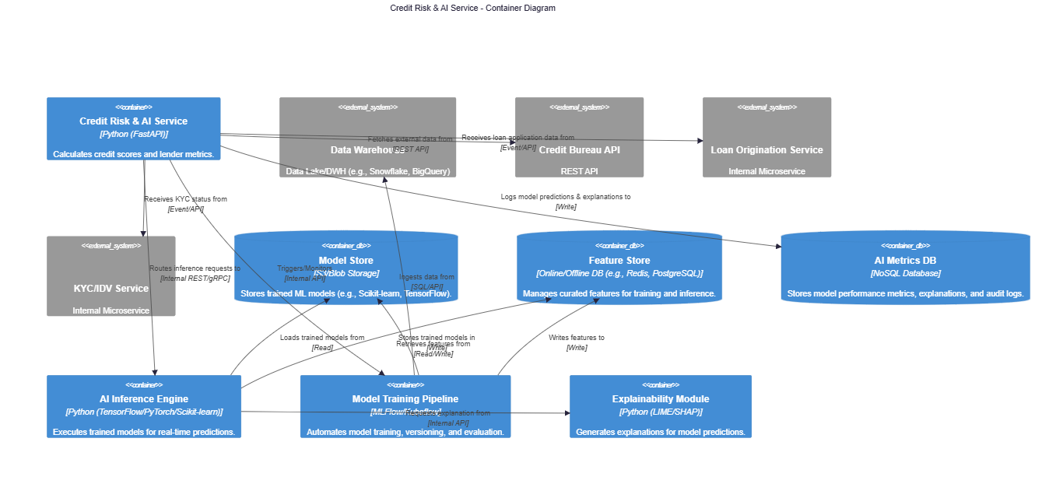

Motivation for Decomposition of Credit Risk & AI Service
The decomposition of the Credit Risk & AI Service into specialized internal components is motivated by:
- Separation of Concerns: Clearly separates model training from inference, and feature engineering from model deployment, enhancing maintainability and allowing independent scaling.
- MLOps Best Practices: Incorporates components for automated training, versioning, monitoring, and explainability, crucial for reliable and responsible AI systems.
- Performance Optimization: An dedicated Inference Engine ensures low latency predictions, while the Feature Store optimizes data access.
- Ethical AI & Compliance: The Explainability Module directly addresses the "Ethical AI" constraint, providing transparency for regulatory bodies and human approvers. The AI Metrics DB stores audit trails related to model decisions.
- Scalability & Flexibility: Allows different parts of the ML pipeline to use specialized tools and scale independently.
Contained Building Blocks (Black Boxes) for Credit Risk & AI Service

Name | Responsibility | Major Interfaces | Code Location
AI Inference Engine | Loads trained ML models from the Model Store and performs real-time predictions (credit scores, lender metrics) based on input features. | POST /predict-credit-score, POST /predict-lender-metric (receives features, returns score/metric). | /services/credit-risk-ai/inference-engine
Model Training Pipeline | Automates the process of data ingestion, feature engineering, model training, validation, and versioning. Triggers retraining based on data drift or performance degradation. | POST /train-model (internal trigger), GET /model-versions, GET /model-metrics | /services/credit-risk-ai/training-pipeline (e.g., using Kubeflow Pipelines)
Feature Store | Centralized repository for curated and transformed data features. Provides consistent feature definitions for both model training and real-time inference, ensuring consistency and preventing data leakage. | GET /features/{entityId} (online retrieval for inference), GET /offline-features (batch retrieval for training). | /services/credit-risk-ai/feature-store
Model Store | Securely stores all versions of trained machine learning models, along with their metadata (e.g., training data, metrics, parameters). | POST /models/upload, GET /models/{version}/download | /services/credit-risk-ai/model-store (e.g., S3 bucket)
Explainability Module | Integrates with the AI Inference Engine to generate human-interpretable explanations for model predictions, identifying key factors influencing a credit decision. | POST /explain-prediction (takes prediction output and features, returns explanation). | /services/credit-risk-ai/explainability
AI Metrics DB | Stores audit logs of model predictions, input features, generated explanations, and historical model performance metrics. Essential for compliance and monitoring. | POST /logs/prediction, GET /metrics/model-performance | /services/credit-risk-ai/metrics-db (e.g., MongoDB for flexibility)
Data Ingestion/Preparation | Handles the extraction, transformation, and loading (ETL) of raw data from internal services (Loan Origination, KYC/IDV) and external sources (Credit Bureau) into the Feature Store or Data Warehouse for training and inference purposes. | Consumes loan_application_submitted, kyc_approved events. Calls Credit Bureau API. Writes to Feature Store. | /services/credit-risk-ai/data-ingestion
5.2.2 White Box: Payment & Escrow Service
The Payment & Escrow Service is paramount for the financial operations of the P2P lending platform, directly handling all money movements and ensuring strict RBI compliance. Its decomposition focuses on financial transaction integrity, secure integration with external financial systems, and robust error handling.
Overview Diagram: Payment & Escrow Service

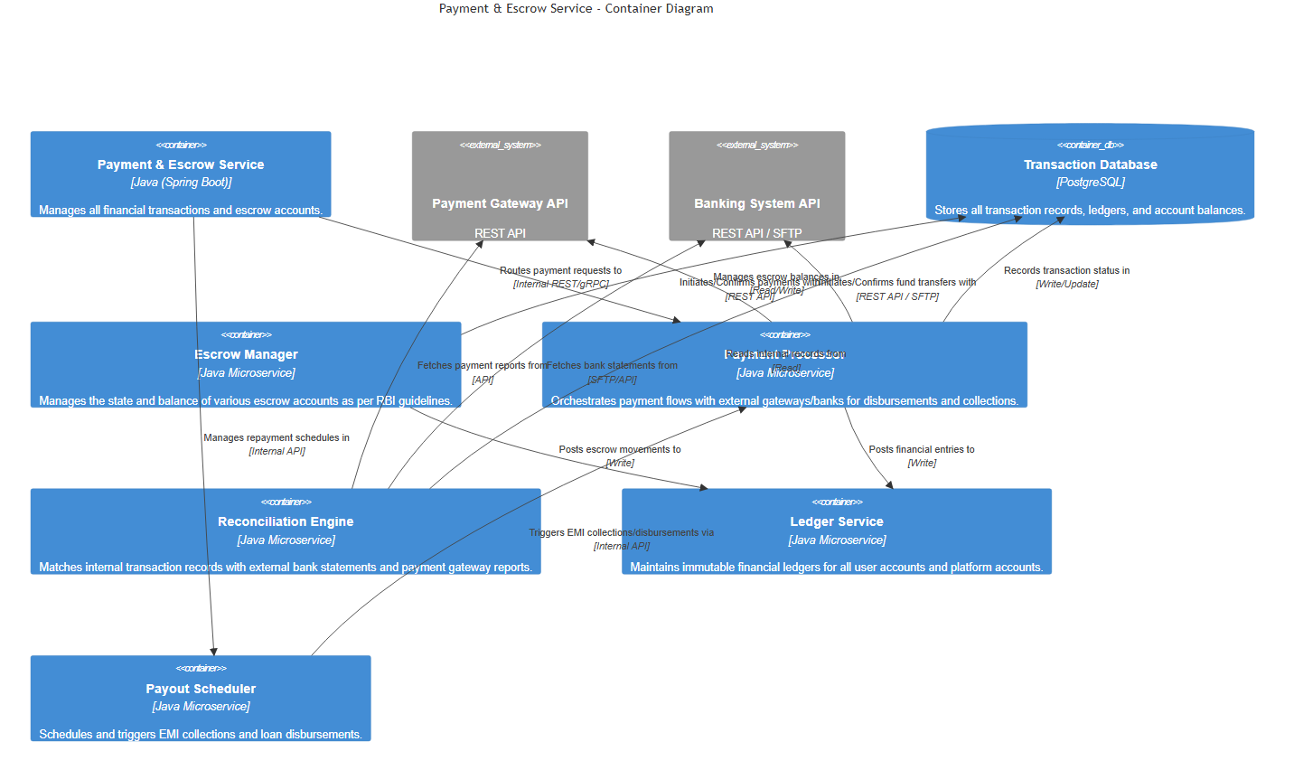

Motivation for Decomposition of Payment & Escrow Service
The internal decomposition of the Payment & Escrow Service is crucial for:
- Financial Integrity & Auditability: Dedicated Ledger and Reconciliation Engines ensure every financial movement is accurately recorded and verifiable, critical for RBI compliance and preventing fraud.
- RBI Compliance: The Escrow Manager specifically implements RBI's guidelines for fund management, while the entire service is designed to maintain stringent security and data privacy.
- Robustness & Error Handling: Separating payment processing from reconciliation and scheduling allows for specialized error handling strategies for each, particularly important given the external dependencies on banks and payment gateways.
- Scalability for Transactions: Specialized components can handle high volumes of transaction processing and batch reconciliation independently.
- Security: Isolates core financial logic into hardened components, allowing for more focused security audits and controls.
Contained Building Blocks (Black Boxes) for Payment & Escrow Service
Name | Responsibility | Major Interfaces | Code Location
Payment Processor | Orchestrates interactions with external Payment Gateways and Banking APIs to initiate and confirm loan disbursements, EMI collections, and other fund transfers. Handles protocol conversions and error retries. | POST /process-payment (initiates payment), GET /payment-status/{id} (queries status), POST /webhook/{gateway} (receives callbacks). | /services/payment-escrow/payment-processor
Escrow Manager | Manages the lifecycle of designated escrow accounts. Ensures funds are held and disbursed strictly according to P2P lending regulations (RBI guidelines), maintaining distinct sub-accounts for various purposes. | POST /escrow/deposit, POST /escrow/release, GET /escrow/balance/{accountId} | /services/payment-escrow/escrow-manager
Ledger Service | Maintains an immutable, double-entry accounting ledger for all financial transactions. Ensures absolute data integrity and provides a verifiable audit trail for every fund movement within the platform. | POST /ledger/post-entry (posts debit/credit entries), GET /ledger/account-statement/{accountId} | /services/payment-escrow/ledger-service
Reconciliation Engine | Periodically compares the platform's internal transaction records (from Transaction Database and Ledger) with statements from external Payment Gateways and Banks to identify discrepancies and ensure financial accuracy. | POST /reconcile-transactions (triggered internally), GET /reconciliation-reports, POST /mark-as-reconciled | /services/payment-escrow/reconciliation-engine
Transaction Database | Stores all detailed records of individual transactions, payment attempts, and their statuses. Provides the source of truth for all current and historical financial movements. | SQL interface; INSERT INTO transactions, UPDATE transactions SET status, SELECT * FROM transactions. | /services/payment-escrow/transaction-db
Payout Scheduler | Schedules and triggers recurring events such as EMI collection attempts and automated loan disbursements based on predefined schedules and platform events. | POST /schedule-emi-collection, POST /schedule-disbursement, GET /scheduled-payouts | /services/payment-escrow/payout-scheduler
Fraud Detection Module | (Sub-component of Payment Processor or dedicated) Monitors transactions for suspicious activities and patterns, integrating with internal and potentially external fraud detection systems. | POST /analyze-transaction-for-fraud (internal call during payment processing). | /services/payment-escrow/fraud-detection

Level 3
This section delves into the inner structure of specific building blocks identified at Level 2, providing a detailed white-box description of their internal components and interactions. For the Leva Devi P2P Lending Platform, we will zoom into the AI Inference Engine within the Credit Risk & AI Service, as it is a core component for real-time decision-making and critical for the "AI/ML Integration" and "Performance/Responsiveness" constraints.
5.3.1 White Box: AI Inference Engine
The AI Inference Engine is responsible for loading trained machine learning models and executing them to generate real-time predictions (e.g., credit scores for borrowers, risk metrics for lenders). Its internal design focuses on efficiency, robustness, and integration with the overall AI ecosystem.
Motivation for Decomposition of AI Inference Engine
The decomposition of the AI Inference Engine into these distinct components is motivated by:
- Modularity & Maintainability: Each component has a single, clear responsibility, making the code easier to understand, test, and maintain.
- Performance Optimization: Specific components (e.g., Feature Transformer, Model Loader) can be optimized independently for speed, crucial for the "<2 seconds for user actions" performance constraint.
- Robustness & Error Handling: Input validation and structured processing allow for more granular error detection and handling, improving system reliability.
- Flexibility & Model Agnosticism: The architecture allows for different types of ML models (e.g., Scikit-learn, TensorFlow, PyTorch) to be integrated by swapping out or adapting the Prediction Executor and Model Loader components, without affecting other parts of the engine.
- Traceability & Explainability: The Explainability Adapter directly facilitates the "Ethical AI" constraint by enabling the generation of model explanations for every prediction, which can be logged in the AI Metrics DB for auditability.
- Resource Management: Caching mechanisms within the Model Loader (e.g., keeping frequently used models in memory) reduce I/O and improve response times.
Contained Building Blocks (Black Boxes) for AI Inference Engine
Name | Responsibility | Major Interfaces | Code Location
Inference API Endpoint | The entry point for external requests to the AI Inference Engine. Validates basic request structure and orchestrates the flow through internal components to generate a prediction. | POST /predict-credit-score, POST /predict-lender-metric (receives raw data, returns prediction). | /services/credit-risk-ai/inference-engine/api
Request Validator | Performs schema validation, type checking, and sanity checks on the incoming request payload to ensure data quality and prevent malformed requests from proceeding. | validate(request_payload): takes raw request, returns validated data or error. | /services/credit-risk-ai/inference-engine/validator
Feature Transformer | Applies all necessary pre-processing steps to the raw input data (e.g., one-hot encoding, scaling, imputation) to transform it into the feature vector expected by the ML model. May interact with the Feature Store. | transform(raw_data): takes raw input, returns engineered features. fetch_features(entity_id): interacts with Feature Store. | /services/credit-risk-ai/inference-engine/feature_transformer
Model Loader | Responsible for loading trained machine learning models from the Model Store into memory. Implements caching strategies to optimize performance by reducing repeated disk/network I/O for frequently used models. | load_model(model_id, version): retrieves model artifact. get_cached_model(model_id): returns cached model. | /services/credit-risk-ai/inference-engine/model_loader
Prediction Executor | Takes the prepared feature vector and the loaded ML model, then executes the model's prediction method to generate the raw output (e.g., a probability score). This component is typically framework-specific. | execute_prediction(model, features): performs model inference, returns raw prediction. | /services/credit-risk-ai/inference-engine/prediction_executor
Response Formatter | Transforms the raw model prediction (e.g., probability) into the desired output format for the API response (e.g., a categorical risk level like 'Low', 'Medium', 'High', or a formatted score). | format_response(raw_prediction): takes raw prediction, returns structured API response. | /services/credit-risk-ai/inference-engine/response_formatter
Explainability Adapter | Acts as a proxy or client to the external Explainability Module. It gathers necessary context (input features, raw prediction) and invokes the explanation generation service, asynchronously if possible. | request_explanation(prediction_id, features, raw_prediction): sends request to external module. handle_explanation_callback(explanation_data): processes results. | /services/credit-risk-ai/inference-engine/explainability_adapter

Runtime View

  - Runtime Scenario 1: Borrower Loan Application & Credit Assessment
This scenario illustrates the end-to-end process of a borrower registering, completing KYC, submitting a loan application, and the system performing an automated credit risk assessment using AI.
Sequence Diagram: Borrower Loan Application & Credit Assessment
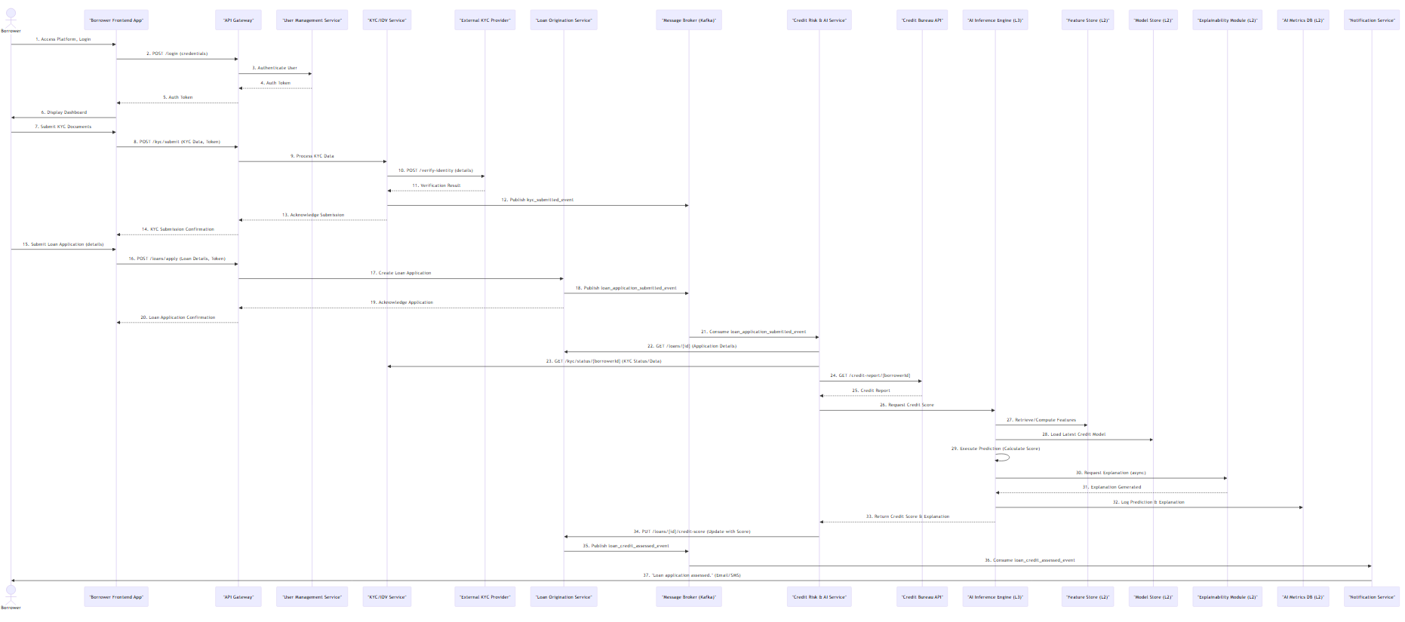

Notable Aspects of Interactions
- API Gateway as Entry Point: All external requests from the Borrower App are routed through the API Gateway, ensuring centralized authentication, authorization, and rate limiting as per security constraints.
- Microservice Collaboration: Multiple services (User Management, KYC/IDV, Loan Origination, Credit Risk & AI) collaborate to fulfill the end-to-end process.
- Asynchronous Processing: The use of a Message Broker (Kafka) for kyc_submitted_event and loan_application_submitted_event decouples services, allowing the Borrower App to receive immediate acknowledgments while complex, time-consuming operations (like external KYC checks or AI processing) happen in the background. This supports "Performance / Responsiveness."
- External System Integration: Direct calls to External KYC Provider and Credit Bureau API demonstrate critical third-party integrations, highlighting dependencies and the need for robust error handling.
- AI/ML Integration (Level 3 Detail): The interaction with the Credit Risk & AI Service shows its internal components at Level 3 (AI Inference Engine, Feature Store, Model Store, Explainability Module, AI Metrics DB), demonstrating how the AI model is leveraged for credit assessment and how "Ethical AI" (via explainability) is incorporated.
- Event-Driven Updates: Events published to the Message Broker (kyc_submitted_event, loan_application_submitted_event, loan_credit_assessed_event) are consumed by relevant services (e.g., Credit Risk & AI, Notification Service) to trigger subsequent actions or inform users.
- Data Consistency: The Loan Origination Service acts as the source of truth for loan application status, being updated by other services with relevant information like credit scores.
- Observability: Logging prediction and explanation data in the AI Metrics DB within the Credit Risk & AI Service ensures auditability and supports model monitoring.

  - 6.2 Runtime Scenario 2: Lender Expresses Willingness & Loan Disbursement
This scenario depicts a lender reviewing approved loan applications, making an offer to fund a loan, the borrower accepting the offer, and the subsequent disbursement of funds to the borrower, involving critical payment and escrow operations.
Sequence Diagram: Lender Expresses Willingness & Loan Disbursement
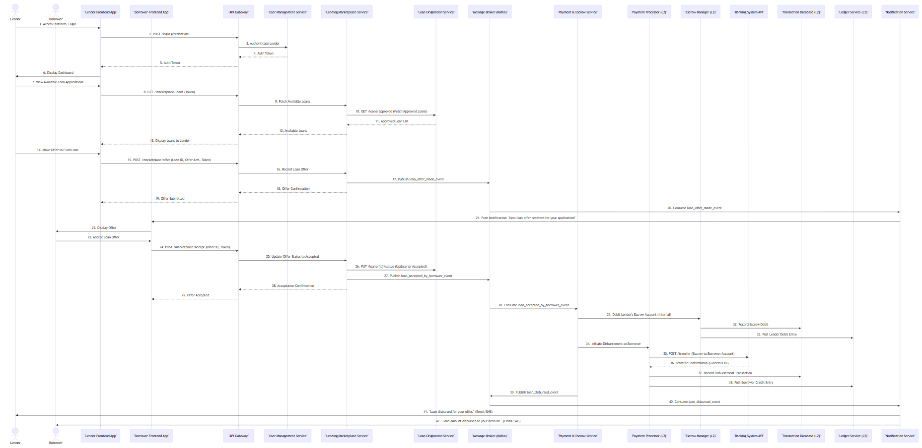
Notable Aspects of Interactions
- Lending Marketplace Core: The Lending Marketplace Service is central to matching borrowers and lenders, managing offers and acceptances.
- Transactional Integrity (Payment & Escrow Service - Level 2 Detail): The Payment & Escrow Service is critical for ensuring the secure and compliant transfer of funds. Its internal components, Payment Processor, Escrow Manager, Transaction Database, and Ledger Service, work together to ensure ACID properties for financial transactions and strict adherence to RBI guidelines.
- External Banking Integration: Direct interaction with Banking System API for fund transfers highlights the need for robust and secure integration with external financial institutions, addressing the "Integration with Financial Institutions" constraint.
- Event-Driven Fund Flow: loan_offer_made_event and loan_accepted_by_borrower_event drive notifications and trigger the fund disbursement process, demonstrating asynchronous workflow.
- Dual Notification: Both borrower and lender receive notifications about critical lifecycle events (offer, acceptance, disbursement), ensuring transparency and fulfilling user tracking requirements.
- Auditability: Every step, particularly within the Payment & Escrow Service, involves recording transactions in the Transaction Database and posting entries to the Ledger Service, which is crucial for "Auditability" and "RBI Compliance."
- Error Handling (Implicit): The flow assumes success; however, in a real system, the Payment Processor would handle potential failures from the Bank API with retry mechanisms and appropriate logging, publishing payment_failed_event to the Message Broker.

Deployment View

Infrastructure Level 1(Production Environment - AWS India Region)

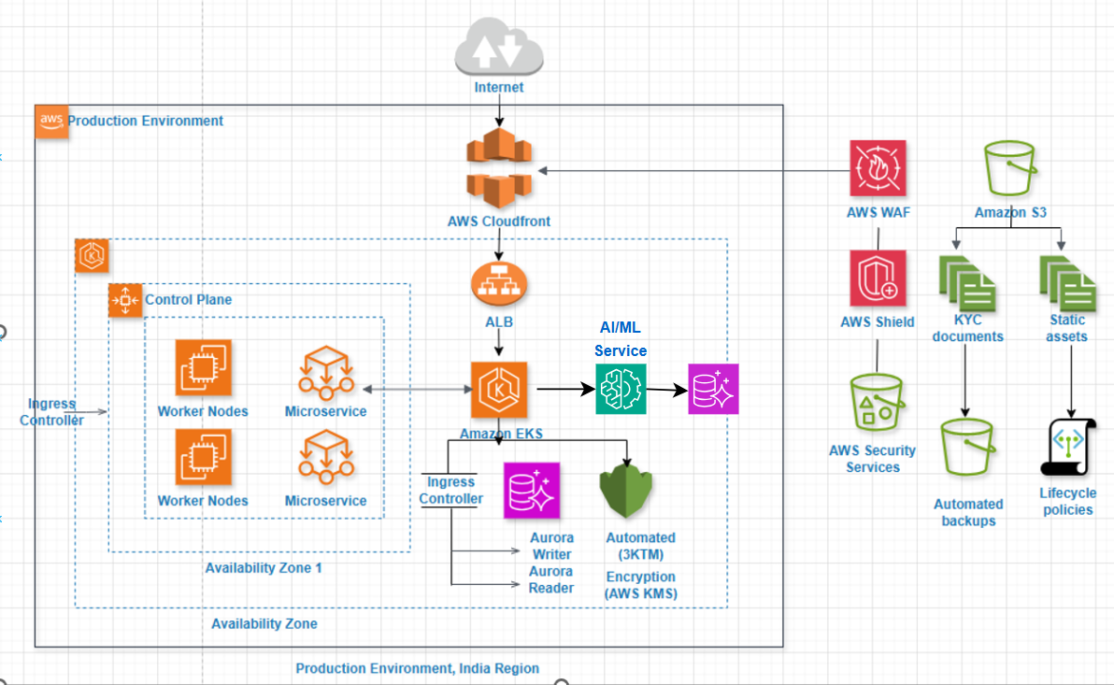
The production infrastructure is built on AWS, leveraging a multi-Availability Zone (AZ) deployment model within an Indian AWS Region (e.g., ap-south-1 - Mumbai) to ensure high availability and resilience.
The AWS deployment strategy is specifically tailored to meet the platform's requirements for:
- High Availability & Disaster Recovery: Leveraging AWS's multi-AZ architecture (e.g., distributing components like ALB, EKS worker nodes, RDS instances, and ElastiCache across different Availability Zones) ensures resilience against AZ-level failures. Aurora's self-healing, distributed storage provides superior fault tolerance.
- Scalability & Performance:
  - Amazon EKS allows for dynamic scaling of application microservices based on demand.
  - AWS Lambda provides serverless compute for event-driven tasks, automatically scaling to handle bursts.
  - Amazon RDS Aurora offers highly scalable database performance.
  - Amazon ElastiCache improves read performance by caching frequently accessed data.
  - Amazon CloudFront (CDN) caches static content closer to users, reducing latency.
  - Application Load Balancers (ALB) efficiently distribute incoming traffic across healthy targets.
- Security & Compliance (RBI Guidelines):
  - AWS WAF protects against common web exploits.
  - AWS VPC with private subnets ensures application and database isolation.
  - AWS IAM provides granular access control.
  - AWS KMS encrypts data at rest and in transit.
  - AWS Secrets Manager securely stores and rotates credentials.
  - Amazon GuardDuty, Security Hub, and Config aid in continuous security monitoring and compliance checks, essential for RBI regulations, including data residency within India.
- Operational Efficiency: Managed services (RDS, ElastiCache, SQS, Lambda, EKS) reduce operational overhead for patching, backups, and infrastructure management, allowing the team to focus on application development.
- Cost Optimization: Pay-as-you-go models and auto-scaling features help optimize infrastructure costs.
Quality and/or Performance Features:
- Uptime Target: Aim for 99.99% availability for core services leveraging AWS's inherent redundancy.
- Latency: Sub-second response times for typical user interactions, enhanced by CloudFront and ElastiCache. API latency under 200ms for 95% of requests.
- Scalability:
  - EKS HPA (Horizontal Pod Autoscaler) for microservices.
  - Lambda's automatic scaling.
  - Aurora's storage auto-scaling and read replicas.
  - Designed to handle a 5x increase in load within an hour.
- Data Durability: Amazon S3 provides 99.999999999% (eleven nines) durability. Aurora's storage is also highly durable.
- Disaster Recovery (DR):
  - RTO < 4 hours, RPO < 15 minutes through multi-AZ deployments and automated RDS failovers.
  - Cross-region DR capabilities can be explored for extreme scenarios if required beyond the initial scope.
- Security: Strong adherence to AWS Well-Architected Framework's security pillar. Regular penetration testing and vulnerability assessments. Data encrypted at rest using KMS and in transit using TLS.
Mapping of Software Artifacts (Building Blocks):
- Frontend Applications (Web/Mobile): Static assets served via Amazon S3 and distributed by Amazon CloudFront. Dynamic API calls routed through ALB.
- API Gateway: Implicitly handled by ALB routing requests to Amazon EKS services. For more advanced API management (e.g., custom authorizers, throttling), Amazon API Gateway could be introduced in front of ALB.
- User Management, Loan Application, Lender Matching, Payment Processing, Notification, Reporting & Analytics Services: Deployed as microservices within Amazon EKS clusters.
- Credit Risk Assessment Service (AI-based) & Lender Metric Algorithm: Can be deployed as microservices within Amazon EKS or as AWS Lambda functions for specific event-driven computations. These might interact with Amazon SageMaker for model training and deployment.
- Document Storage Service: Leverages Amazon S3 for secure, scalable object storage of KYC and other documents.
- Message Broker: Implemented using Amazon SQS for reliable asynchronous messaging between microservices and Amazon SNS for publish/subscribe patterns (e.g., notifications).
- Managed Database: Amazon RDS Aurora (PostgreSQL compatible) for transactional data.
- Caching Layer: Amazon Elasti-Cache (Redis) for high-speed data retrieval.
- Logging & Monitoring: Amazon CloudWatch for collecting logs, metrics, and setting up alarms. AWS X-Ray for distributed tracing.
- Identity & Access Management: AWS IAM for managing permissions for all AWS resources and services. AWS Cognito can be used for user authentication and authorization for the application itself.
- CI/CD: AWS Code-Pipeline, AWS Code-Build, AWS Code-Deploy (integrated with EKS) for automated software delivery.
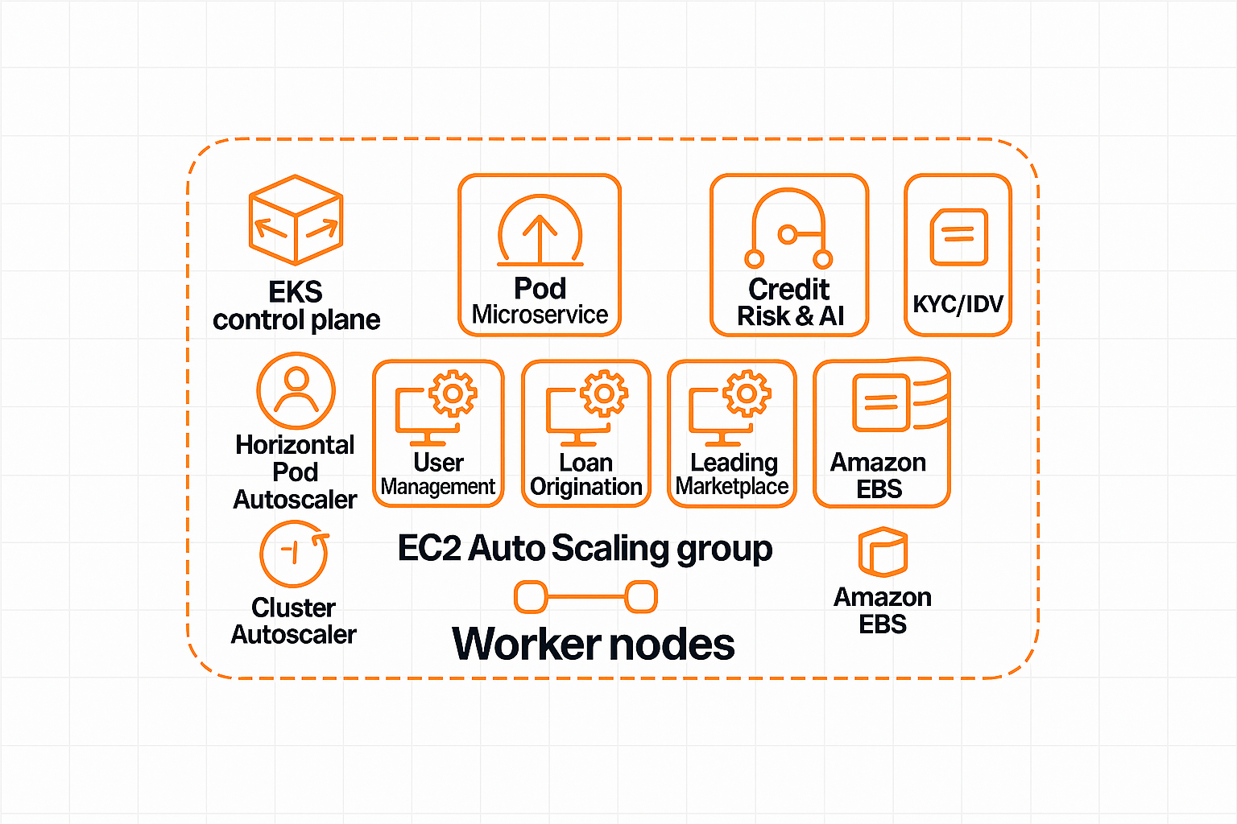
Worker nodes in an EKS cluster host containerized microservices such as User Management, Loan Origination, Lending Marketplace, Credit Risk & AI, and KYC/IDV. They leverage EC2 Auto Scaling, Horizontal Pod Auto-Scaler, and Cluster Auto-Scaler for dynamic scaling, with Amazon EBS providing persistent storage.

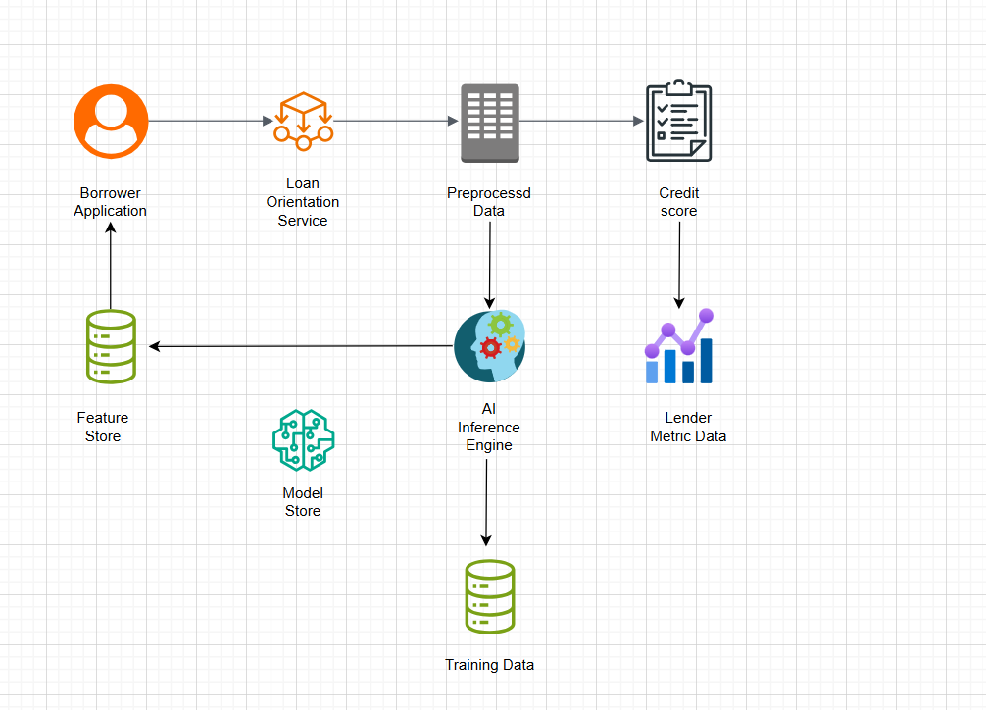
- Borrower Application → Captures loan request details.
- Loan Origination Service → Sends data for preprocessing.
- Preprocessed Data → Cleaned and structured for AI model.
- AI Inference Engine → Uses features from Feature Store and models from Model Store.
- Credit Score Generation → Output for borrower risk assessment.
- Lender Metrics → Provides insights for lenders.
- Training Data Loop → Updates models periodically for accuracy.

7.2 Infrastructure Level 2
This section details the internal structure of key AWS infrastructure elements.
7.2.1 Application Servers (Amazon EKS Cluster)
The application microservices are deployed on Amazon Elastic Kubernetes Service (EKS), providing a fully managed Kubernetes control plane and allowing for highly scalable and resilient container orchestration.
The core application logic runs on an Amazon EKS cluster:
- EKS Control Plane: Fully managed by AWS, it handles the Kubernetes API server, etcd, scheduler, and controllers, removing the operational burden of managing master nodes.
- EC2 Auto Scaling Group for Worker Nodes: EC2 instances (e.g., M5 or C5 families) form the worker nodes where application pods run. An Auto Scaling Group ensures that the desired number of healthy worker nodes is always available, scaling automatically based on demand.
- Pods: Containerized microservices (e.g., User Management, Loan Application, Credit Risk) are deployed as pods onto the worker nodes.
- AWS ALB (Kubernetes Ingress Controller): An Ingress controller running within EKS provisions and manages AWS Application Load Balancers, routing external HTTP/HTTPS traffic to the appropriate Kubernetes services and pods.
- Kubernetes Services: Abstract the underlying pods, providing a stable network endpoint for applications.
- Amazon ECR (Elastic Container Registry): Used to store and manage the Docker images for all microservices. The EKS worker nodes pull these images during deployment.
- Amazon EBS (Elastic Block Store): Provides persistent block storage for pods that require it (e.g., for stateful applications, though most microservices are designed to be stateless).
- Horizontal Pod Autoscaler (HPA): Automatically adjusts the number of pods in a deployment or replica set based on observed CPU utilization or other select metrics.
- Cluster Autoscaler: Automatically adjusts the number of worker nodes in the EKS cluster, scaling up when pods are pending due to insufficient resources and scaling down when nodes are underutilized.
- AWS IAM for Service Accounts: Enables fine-grained access control for pods to interact with other AWS services (e.g., S3, RDS, SQS).
7.2.2 Managed Database (Amazon RDS Aurora PostgreSQL)
The primary data store for the platform is Amazon RDS Aurora compatible with PostgreSQL, chosen for its high performance, scalability, and robust high-availability features.
Amazon RDS Aurora provides a highly available and scalable relational database solution:
- Aurora Writer Instance (Primary): Handles all write operations and can also serve read requests. It automatically fails over to a reader instance in case of an issue.
- Aurora Reader Instances: Dedicated instances for read-heavy workloads, distributing the read load and improving application performance. These are deployed across multiple Availability Zones for high availability.
- Aurora Shared, Distributed Storage: A unique feature of Aurora where the storage is decoupled from compute and replicated 6 ways across 3 Availability Zones automatically, providing high durability and fast recovery. All instances in the cluster share this single, logical storage volume.
- Automated Backups & Point-in-time Recovery: Aurora continuously backs up data to S3, enabling point-in-time recovery for up to 35 days.
- Automated Failover: In case the primary writer instance fails, Aurora automatically promotes a reader instance to become the new writer with minimal downtime, typically under 30 seconds.
- AWS KMS: All data stored in Aurora (at rest) is encrypted using AWS Key Management Service (KMS) for enhanced security and compliance.
- Amazon CloudWatch: Provides detailed metrics and logs for the Aurora cluster, enabling monitoring of performance, health, and setting up alarms.
- Optional Global Database: For extreme disaster recovery scenarios or global reach, Aurora Global Database can provide cross-region replication with low latency, allowing for rapid recovery in another AWS Indian region (e.g., Hyderabad if available and required by RBI).
7.2.3 Object Storage (Amazon S3)
Amazon S3 (Simple Storage Service) is used for highly durable, scalable, and secure object storage for unstructured data like KYC documents, images, and static website content.
Amazon S3 provides robust object storage:
- S3 Buckets: Data is stored in buckets (e.g., dedicated buckets for KYC documents, static website assets).
- Highly Durable and Available: S3 stores objects redundantly across multiple devices and multiple facilities within an AWS Region, providing 99.999999999% durability.
- Scalability: Infinitely scalable, accommodating any amount of data.
- Security:
  - AWS KMS: Objects are encrypted at rest using server-side encryption with KMS keys.
  - AWS IAM: Granular access control policies define who can access what data.
  - VPC Endpoints for S3: Ensures private access to S3 from within the VPC without traversing the internet.
- Versioning: S3 Versioning keeps multiple versions of an object, protecting against accidental deletions or overwrites.
- Lifecycle Policies: Automate the transition of data to lower-cost storage classes (e.g., S3 Glacier) or deletion after a certain period, crucial for managing data retention and compliance.
- CloudFront Integration: S3 buckets hosting static web assets are integrated with Amazon CloudFront to deliver content globally with low latency.

Crosscutting Concepts
8.1 Security and Compliance (RBI Guidelines)
Motivation: For a financial platform operating in India, security and adherence to Reserve Bank of India (RBI) guidelines are non-negotiable. This concept impacts every layer of the architecture, from infrastructure to application code and operational processes.
Key Principles & Decisions:
- Data Residency: All sensitive customer data (KYC, financial transactions) must reside within India, aligning with RBI's data localization requirements. AWS Mumbai region (ap-south-1) is selected to meet this.
- Encryption:
  - Data at Rest: All sensitive data stored in databases (RDS Aurora), object storage (S3), and backups must be encrypted using AWS Key Management Service (KMS) with customer-managed keys (CMKs) where appropriate.
  - Data in Transit: All communication, internal and external (APIs, UI), must use Transport Layer Security (TLS 1.2 or higher) with strong ciphers.
- Access Control (Least Privilege):
  - IAM: AWS Identity and Access Management (IAM) is used for granular access control to AWS resources.
  - Application-Level RBAC: Role-Based Access Control (RBAC) will be implemented within the application for users (Borrower, Lender, Approver, Management) to ensure they only access authorized features and data.
  - Service Accounts: Microservices will use dedicated IAM roles or Kubernetes Service Accounts with the minimum necessary permissions.
- Network Security:
  - VPC: Network isolation through AWS VPC with private subnets for application servers and databases.
  - Security Groups & Network ACLs: Strict firewall rules to control traffic ingress and egress.
  - AWS WAF: Protects against common web exploits (OWASP Top 10) at the application layer.
  - DDoS Protection: Leveraging AWS Shield Standard, with potential for Shield Advanced for higher protection.
- Auditing and Logging:
  - Centralized Logging: All application, infrastructure, and security logs (CloudTrail, VPC Flow Logs, application logs) are centralized in Amazon CloudWatch Logs and potentially exported to S3 for long-term retention and analysis.
  - Audit Trails: Comprehensive audit trails for all critical actions (e.g., loan application submission, approval, payment initiation) must be maintained for compliance.
- Vulnerability Management: Regular security assessments, penetration testing, and vulnerability scanning of applications and infrastructure.
- Secure Development Lifecycle (SDL): Integrating security practices into the CI/CD pipeline, including static and dynamic application security testing (SAST/DAST).
8.2 Scalability and High Availability
Motivation: The platform needs to support a growing user base and transaction volume without performance degradation, ensuring continuous operation (24/7) as per the problem statement.
Key Principles & Decisions:
- Microservices Architecture: Decomposing the system into smaller, independently deployable services allows for individual scaling and easier management.
- Stateless Services: Most microservices should be stateless to facilitate horizontal scaling by adding more instances. State will be managed in external, highly available data stores (e.g., RDS Aurora, ElastiCache).
- Containerization (Kubernetes): Using Docker containers orchestrated by Amazon EKS provides efficient resource utilization, portability, and auto-scaling capabilities (Horizontal Pod Autoscaler for pods, Cluster Autoscaler for nodes).
- Managed Services: Leveraging AWS managed services (RDS Aurora, ElastiCache, SQS, Lambda) reduces operational overhead and inherits their built-in scalability and high availability features.
- Multi-AZ Deployment: Deploying critical components (EKS worker nodes, ALB, RDS primary/replica, ElastiCache) across multiple Availability Zones within the AWS Mumbai region to ensure resilience against AZ failures.
- Load Balancing: AWS Application Load Balancers (ALB) distribute incoming traffic across multiple instances/pods, ensuring even load distribution and high availability.
- Asynchronous Processing: Using message queues (Amazon SQS) and event streams (Amazon SNS) to decouple services, handle peak loads, and improve overall system responsiveness and fault tolerance.
- Read Replicas: Utilizing Amazon RDS Aurora read replicas to offload read-heavy workloads from the primary database, improving database performance and scalability.
- Caching: Implementing Amazon ElastiCache (Redis) to cache frequently accessed data, reducing database load and improving response times.
8.3 Performance
Motivation: A seamless user experience requires quick response times for all interactions, as highlighted in the additional information.
Key Principles & Decisions:
- Content Delivery Network (CDN): Amazon CloudFront will cache static assets (UI files, images, documents) geographically closer to users, reducing latency.
- Efficient Database Queries: Optimizing database schemas and queries, using appropriate indexing, and leveraging connection pooling.
- API Optimization: Designing RESTful APIs with efficient data transfer, pagination, and caching headers.
- Asynchronous Operations: Offloading long-running processes (e.g., complex AI calculations, document processing) to background tasks using Lambda or message queues to avoid blocking user requests.
- Microservice Responsiveness: Each microservice should be designed for optimal performance, minimizing internal latency and external dependencies where possible.
- Monitoring: Continuous monitoring of response times at various layers (CDN, ALB, application, database) using Amazon CloudWatch and X-Ray to identify and resolve performance bottlenecks proactively.
8.4 Data Management and Persistence
Motivation: Secure, reliable, and scalable storage and retrieval of various data types are fundamental to the platform's operation and compliance.
Key Principles & Decisions:
- Relational Database for Transactional Data: Amazon RDS Aurora (PostgreSQL compatible) will be the primary data store for all transactional data (user profiles, loan applications, loan agreements, payment schedules, audit trails).
- Object Storage for Unstructured Data: Amazon S3 will be used for storing unstructured data such as KYC documents, user-uploaded images, and potentially large reports.
- Caching for Read Performance: Amazon ElastiCache (Redis) will serve as an in-memory data store for caching frequently accessed data (e.g., user sessions, popular loan listings, credit scores) to reduce database load and improve response times.
- Data Encryption: All data at rest and in transit will be encrypted as per security guidelines (see 8.1).
- Backup and Recovery: Automated backups and point-in-time recovery for Aurora, coupled with S3's high durability, ensure data integrity and disaster recovery capabilities.
- Data Retention Policies: Implementing S3 Lifecycle Policies and database archiving strategies to meet regulatory data retention requirements while managing storage costs.
8.5 API-First Approach
Motivation: The problem statement explicitly mentions providing APIs for financial institutions. An API-first approach promotes reusability, modularity, and easier integration with external partners.
Key Principles & Decisions:
- External and Internal APIs: Distinct API layers for external partners and internal microservice communication.
- RESTful APIs: Design APIs following REST principles, using clear and consistent resource naming, HTTP methods, and status codes.
- API Documentation: Comprehensive API documentation (e.g., OpenAPI/Swagger) for all exposed APIs to facilitate consumption by internal and external developers.
- API Security: Implementing robust authentication (e.g., OAuth 2.0, API keys), authorization, and throttling for external APIs.
- Versioning: Plan for API versioning from the outset to manage changes without breaking existing integrations.
- API Gateway (Potential): While ALB can route, a dedicated Amazon API Gateway could be introduced later for advanced features like custom authorizers, usage plans, throttling, and direct service integrations (e.g., Lambda).
8.6 AI/ML Integration
Motivation: The platform requires AI-based algorithms for credit risk assessment for borrowers and appropriate metrics for lenders.
Key Principles & Decisions:
- Dedicated AI/ML Services: Credit risk and lender metric algorithms will be implemented as independent microservices or AWS Lambda functions.
- Machine Learning Operations (MLOps): Utilizing AWS SageMaker for building, training, and deploying ML models, ensuring reproducibility, versioning, and monitoring of models.
- Data Pipelines: Establishing robust data pipelines (e.g., using AWS Glue, Lambda, SQS) to feed training data to SageMaker and inference data to the deployed models.
- Real-time vs. Batch Processing: Evaluate whether credit risk assessment requires real-time inference during loan application or can be a batch process, influencing architectural choices.
- Explainability & Auditability: Ensuring that AI model decisions are explainable and auditable, especially in a regulated financial environment, to comply with potential future fairness and transparency regulations.
8.7 Monitoring, Logging, and Alerting
Motivation: Essential for operational visibility, proactive issue detection, performance analysis, and security auditing.
Key Principles & Decisions:
- Centralized Logging: Aggregate all logs (application, infrastructure, network) into Amazon CloudWatch Logs. Use structured logging (JSON) for easier parsing and analysis.
- Metrics Collection: Collect system and application metrics using Amazon CloudWatch (for AWS services) and Prometheus/Grafana (within EKS for microservices).
- Distributed Tracing: Implement AWS X-Ray for end-to-end visibility of requests across microservices, aiding in performance debugging.
- Alerting: Configure CloudWatch Alarms on critical metrics and log patterns to notify operations teams via SNS (email, SMS, PagerDuty integration) of potential issues.
- Dashboards: Create comprehensive monitoring dashboards using CloudWatch or Grafana to visualize system health, performance, and key business metrics.
8.8 Cloud Agnosticism / Flexibility
Motivation: The additional information mentions that the platform must support easy transitions across various cloud service providers. While AWS is the chosen provider, architectural decisions should ideally not create vendor lock-in where avoidable.
Key Principles & Decisions:
- Containerization: Using Docker and Kubernetes (EKS) provides a significant degree of portability, as containers can theoretically run on any cloud or on-premise Kubernetes cluster.
- Managed Service Abstraction: Where possible, leverage services that have cloud-agnostic alternatives or abstract their usage (e.g., using a common database driver rather than AWS-specific SDKs in application code unless necessary).
- Open Standards: Favoring open standards (REST, SQL, OAuth, OpenTelemetry) over proprietary AWS-specific protocols for communication and data formats.
- Infrastructure as Code (IaC): Using tools like Terraform or AWS CloudFormation allows infrastructure definitions to be templated and potentially adapted for other cloud providers with less effort than manual configurations.
- Avoid Deep Vendor-Specific Integrations: While using AWS services, prioritize those with clear conceptual parallels in other clouds, and limit tight coupling to highly proprietary AWS features unless critical for specific requirements.
8.9 Continuous Integration and Continuous Delivery (CI/CD)
Motivation: To achieve rapid time-to-market and ensure reliable, frequent deployments with high quality.
Key Principles & Decisions:
- Automated Builds and Testing: Implement automated build processes, unit tests, integration tests, and static code analysis in the pipeline.
- Automated Deployment: Automate the deployment of microservices to the EKS cluster using AWS CodePipeline and CodeBuild, integrating with Kubernetes deployment strategies (e.g., rolling updates, blue/green deployments).
- Environment Parity: Strive for environment parity between development, staging, and production environments to minimize deployment issues.
- Rollback Capability: Ensure automated rollback mechanisms are in place for deployments in case of failures.
- Observability in Pipeline: Integrate monitoring and alerting into the pipeline to quickly detect and report issues.

Architecture Decisions
9.1 Architectural Style: Microservices Architecture
- Decision: Adopt a Microservices Architecture.
- Context: The platform needs to be highly scalable, maintainable, support rapid development cycles, and evolve independently for various functional domains (User, Loan, Payment, AI). The problem statement implies a complex system with multiple distinct functionalities.
- Alternative Options:
  - Monolithic Architecture: Rejected due to inherent challenges with scalability, independent deployment, technology lock-in, and resilience in a fast-growing startup environment.
- Rationale: * Scalability: Allows individual services to scale independently based on demand, optimizing resource utilization.
  - Resilience: Failure in one service is less likely to affect the entire system.
  - Agility: Enables independent development, deployment, and updates of services by small, dedicated teams.
  - Technology Heterogeneity: Supports using the "right tool for the job" for different services, e.g., Python for AI services, Java/Go for core transaction services.
  - Maintainability: Smaller codebases are easier to understand, manage, and refactor.
- Implications:
  - Increased Operational Complexity: Requires robust orchestration (Kubernetes), monitoring, and distributed tracing.
  - Distributed Data Management: Requires careful consideration of data consistency across services.
  - Inter-service Communication: Needs robust mechanisms like message queues and RESTful APIs.
  - Strong DevOps Culture: Essential for managing deployments and operations effectively.
- Status: Accepted
9.2 Cloud Provider: Amazon Web Services (AWS)
- Decision: Host the entire platform on Amazon Web Services (AWS), specifically within an Indian AWS Region (e.g., ap-south-1 - Mumbai).
- Context: The platform requires high availability, scalability, robust security, and compliance with Indian regulations (especially RBI data residency). The success criteria emphasize high availability, scalability, and security.
- Alternative Options:
  - Other Public Clouds (Azure, GCP): Considered but AWS has a strong presence, mature service offerings, and extensive documentation, making it a well-understood and reliable choice for many startups. Also, the availability of an Indian region for data residency is critical.
  - On-Premise/Hybrid Cloud: Rejected due to significant upfront investment, operational overhead, lack of inherent scalability, and slower time-to-market.
- Rationale:
  - RBI Compliance: AWS provides regions within India (Mumbai, Hyderabad) to ensure data residency requirements are met.
  - Comprehensive Service Offering: AWS provides a vast ecosystem of managed services (compute, database, networking, security, AI/ML) that accelerate development and reduce operational burden.
  - Scalability & Reliability: AWS's global infrastructure and multi-AZ designs offer inherent high availability and scalability.
  - Security Features: Robust security controls and compliance certifications built into the platform.
  - Developer Tooling: Mature CI/CD tools and integration with open-source technologies.
- Implications:
  - Vendor Lock-in (Mitigated): While specific AWS services are used, efforts will be made to use open standards (Kubernetes, PostgreSQL, Redis, REST APIs) to mitigate deep vendor lock-in as much as possible, as per the cross-cutting concern of cloud flexibility.
  - Cost Management: Requires careful cost monitoring and optimization using AWS tools.
  - AWS Expertise: Requires the team to develop strong expertise in AWS services and best practices.
- Status: Accepted
9.3 Container Orchestration: Amazon Elastic Kubernetes Service (EKS)
- Decision: Utilize Amazon EKS for deploying and managing microservices.
- Context: Microservices architecture requires a robust container orchestration platform to manage deployments, scaling, service discovery, and resilience.
- Alternative Options:
  - AWS ECS (Elastic Container Service): Considered as a simpler, AWS-native option. Rejected because Kubernetes offers broader portability, a larger community, and more advanced features for complex microservice deployments, aligning better with potential future multi-cloud flexibility.
  - AWS Fargate: Considered for serverless containers. Rejected for core application services initially to allow for more granular control over underlying EC2 instances and cost optimization, though Fargate could be used for specific workloads later.
- Rationale:
  - Scalability & Resilience: EKS provides a managed Kubernetes control plane, and worker nodes in Auto Scaling Groups, with auto-scaling (HPA, Cluster Autoscaler) for application pods and underlying infrastructure.
  - Portability: Kubernetes is an industry standard, facilitating potential migration to other cloud providers or on-premise solutions if required in the future.
  - Feature Richness: Comprehensive features for service discovery, load balancing, secret management, and extensibility via custom resources and operators.
  - Community Support: Large and active community, extensive tooling.
- Implications:
  - Kubernetes Learning Curve: Requires team members to have or develop Kubernetes operational expertise.
  - Configuration Management: Managing Kubernetes manifests and Helm charts adds a layer of complexity to deployments.
  - Cost: EKS control plane has a cost, plus the cost of underlying EC2 worker nodes.
- Status: Accepted
9.4 Primary Database: Amazon RDS Aurora PostgreSQL
- Decision: Use Amazon RDS Aurora with PostgreSQL compatibility as the primary relational database.
- Context: The platform requires a highly available, scalable, performant, and durable relational database for transactional data (user data, loan applications, payment records). Strict data consistency is crucial.
- Alternative Options:
  - Self-managed PostgreSQL on EC2: Rejected due to significant operational overhead for patching, backups, scaling, and high availability.
  - Other RDS engines (e.g., MySQL): Aurora PostgreSQL offers superior performance and scalability compared to standard RDS engines for demanding workloads, and PostgreSQL has advanced features well-suited for complex financial logic.
  - NoSQL Databases (DynamoDB, MongoDB): Rejected for primary transactional data due to the inherent need for strong ACID properties and complex relational queries, although NoSQL could be used for specific use cases (e.g., event logs, analytics).
- Rationale:
  - High Availability & Durability: Aurora's architecture with shared, distributed storage replicated 6 ways across 3 AZs provides high durability and automatic failover, meeting the 24/7 availability requirement.
  - Scalability: Supports up to 15 read replicas, auto-scaling storage, and high-performance throughput.
  - Performance: Significantly outperforms standard PostgreSQL RDS instances under heavy loads.
  - Cost-Effectiveness: Pay-as-you-go model for storage and compute, eliminating the need to provision large instances upfront.
  - Managed Service: Reduces operational burden compared to self-managed databases.
- Implications:
  - Cost: Aurora can be more expensive than standard RDS for smaller workloads, but cost-effective at scale due to performance and managed nature.
  - Vendor-Specific Features: While PostgreSQL compatible, some Aurora-specific optimizations might make migration to non-Aurora PostgreSQL slightly more involved.
- Status: Accepted
9.5 Unstructured Data Storage: Amazon S3
- Decision: Store all unstructured data, such as KYC documents, images, and static frontend assets, in Amazon S3.
- Context: The platform needs a highly durable, scalable, and cost-effective solution for storing large volumes of various unstructured files, particularly sensitive KYC documents which require robust security.
- Alternative Options:
  - Attaching EBS volumes to EC2/EKS nodes: Rejected as not designed for large-scale, shared object storage; lacks the inherent durability, availability, and cost-effectiveness of S3 for this use case.
  - Database BLOBs: Rejected due to performance implications, increased database size, and complexity of handling large binary objects within a relational database.
- Rationale:
  - Durability & Availability: S3 provides eleven nines of durability and high availability, ensuring data is not lost and is always accessible.
  - Scalability: Infinitely scalable, eliminating concerns about storage capacity planning.
  - Cost-Effective: Tiered storage classes (Standard, Infrequent Access, Glacier) allow for cost optimization based on access patterns.
  - Security: Native integration with KMS for encryption at rest, IAM for granular access control, and VPC Endpoints for private network access.
  - Integration: Seamless integration with other AWS services like CloudFront for content delivery.
- Implications:
  - Access Patterns: Requires careful design of access patterns and IAM policies to ensure secure and controlled access to objects.
  - Data Consistency Model: S3 offers eventual consistency for some operations, which needs to be considered for specific application logic (e.g., immediately after an overwrite, a read might return the old data).
- Status: Accepted
9.6 Messaging and Eventing: Amazon SQS and SNS
- Decision: Utilize Amazon SQS for message queuing and Amazon SNS for publish/subscribe messaging.
- Context: The microservices architecture requires robust asynchronous communication mechanisms to decouple services, handle background tasks, manage notifications, and ensure system resilience during peak loads.
- Alternative Options:
  - Kafka (e.g., Amazon MSK): Considered for high-throughput streaming scenarios. Rejected for initial phase due to higher operational complexity; SQS/SNS are simpler to integrate and manage for standard message queuing and pub/sub needs. Could be adopted later for event streaming.
  - Direct API calls: Used for synchronous communication, but insufficient for background tasks and decoupling.
- Rationale:
  - Decoupling: Services can communicate without direct knowledge of each other, improving fault tolerance.
  - Scalability: Both SQS and SNS scale automatically to handle message volumes.
  - Reliability: SQS guarantees message delivery (at least once) and persistence. SNS ensures fan-out to multiple subscribers.
  - Managed Services: Reduces operational burden for message broker management.
  - Integration: Seamless integration with other AWS services (Lambda, CloudWatch).
- Implications:
  - Eventual Consistency: Systems relying heavily on asynchronous messaging will exhibit eventual consistency, requiring careful application design.
  - Message Ordering: SQS Standard does not guarantee strict ordering (SQS FIFO does, but comes with throughput limitations). This needs to be considered for critical sequences.
  - Monitoring Complexity: Tracing messages across multiple queues and topics requires good monitoring and logging practices.
- Status: Accepted
9.7 Caching Strategy: Amazon ElastiCache for Redis
- Decision: Implement a caching layer using Amazon ElastiCache for Redis.
- Context: To improve application performance, reduce database load, and enhance responsiveness, especially for frequently accessed data like user sessions, common lookups, and calculated credit scores.
- Alternative Options:
  - Application-level caching (in-memory): Rejected for shared, distributed state across multiple microservice instances, as it's difficult to maintain consistency and scale.
  - Other ElastiCache engines (Memcached): Redis was chosen over Memcached for its richer data structures (lists, sets, hashes), persistence options, and pub/sub capabilities, which offer more flexibility for future use cases.
- Rationale:
  - Performance: Dramatically reduces latency for read-heavy operations by serving data from fast in-memory stores.
  - Scalability: ElastiCache clusters can be scaled horizontally.
  - Managed Service: AWS handles provisioning, patching, backup, and failure recovery.
  - Data Structures: Redis offers versatile data structures suitable for various caching patterns (session store, leaderboards, real-time analytics).
  - High Availability: Can be deployed in a multi-AZ configuration with replication.
- Implications:
  - Cache Invalidation Strategy: Requires careful design of cache invalidation or expiration policies to ensure data freshness.
  - Consistency Model: Caches typically provide eventually consistent data; application logic must handle potential staleness.
  - Cost: ElastiCache adds to the overall infrastructure cost.
- Status: Accepted
9.8 AI/ML Platform: AWS SageMaker for Model Training and Deployment
- Decision: Utilize AWS SageMaker for the development, training, and deployment of AI-based algorithms (e.g., credit risk assessment).
- Context: The problem statement explicitly requires AI-based algorithms for credit risk and lender metrics. These models need a robust platform for experimentation, training, deployment, and MLOps.
- Alternative Options:
  - Custom ML Infrastructure on EKS: Rejected for initial phase due to complexity of managing ML lifecycle (data pipelines, model versioning, GPU acceleration, endpoint management) from scratch.
  - Other ML platforms (e.g., Google AI Platform, Azure ML): Rejected due to the primary decision to use AWS.
- Rationale:
  - End-to-End ML Lifecycle: SageMaker provides comprehensive tools for data preparation, model training, hyperparameter tuning, model deployment (real-time endpoints or batch transforms), and monitoring.
  - Managed Service: Reduces the operational overhead of managing ML infrastructure.
  - Scalability: Easily scales compute resources for training and inference.
  - Integration: Integrates seamlessly with other AWS services (S3 for data, Lambda for triggers, CloudWatch for monitoring).
  - MLOps Capabilities: Supports versioning, A/B testing, and monitoring of deployed models.
- Implications:
  - SageMaker Learning Curve: Requires expertise in SageMaker ecosystem.
  - Cost: SageMaker can be costly, especially for large-scale training and high-volume real-time inference endpoints.
  - Data Governance: Requires robust data governance for features used in model training, especially sensitive financial data.
- Status: Accepted
9.9 Security Framework: Layered Security Approach
- Decision: Implement a layered security approach encompassing network, infrastructure, application, and data security, with a strong focus on identity and access management.
- Context: Security is paramount for a financial platform, especially with strict RBI guidelines regarding data privacy, transaction security, and auditability.
- Alternative Options:
  - Relying solely on AWS native security: Rejected as application-level security, secure coding practices, and business logic validation are equally critical and cannot be fully outsourced.
- Rationale:
  - Defense-in-Depth: Multiple layers of security reduce the risk of a breach, as compromising one layer doesn't immediately compromise the entire system.
  - RBI Compliance: Addresses various aspects of RBI guidelines for financial institutions, including data encryption, access control, audit trails, and network isolation.
  - Proactive Threat Mitigation: Combines preventative measures (VPC, WAF, Security Groups, IAM) with detective controls (CloudWatch, GuardDuty, CloudTrail).
- Implications:
  - Complexity: Requires careful configuration and management across multiple security services and layers.
  - Continuous Monitoring: Demands ongoing monitoring, auditing, and vulnerability management.
  - Developer Training: Requires developers to be educated on secure coding practices and security best practices.
- Status: Accepted

Quality Requirements

Quality Requirements
The following table provides an overview and summary of the key quality requirements for the platform, categorized for clarity.
Category | Quality Requirement Summary | Reference to Section 8
Performance Efficiency | The platform must deliver quick response times for all user interactions, handle high transaction volumes efficiently, and ensure seamless interaction even during peak loads. | 8.3 Performance
Reliability | The system must be highly available, guaranteeing uninterrupted access and operations round the clock (24/7). It must be fault-tolerant, resilient to component failures, and capable of quick recovery with no data loss. | 8.2 Scalability and High Availability (Availability aspect) <br/> 8.4 Data Management and Persistence (Durability)
Security & Compliance | The platform must be secure against cyber threats, protect user data (confidentiality, integrity), and strictly adhere to RBI guidelines for P2P lending platforms in India, including data residency, transaction security, and auditability. | 8.1 Security and Compliance (RBI Guidelines)
Scalability | The system must be capable of supporting a growing load of users and transactions effectively and efficiently with minimal adaptations, scaling horizontally to meet increasing demand without performance degradation. | 8.2 Scalability and High Availability
Usability | The platform must be easy to use and navigate for all user types (Borrowers, Lenders, Approvers, Management). It should be accessible across various devices (mobile, tablet, laptop, desktop) and provide an intuitive user experience. | Implicit in "ease of use are critical factors"
Maintainability | The system should be designed for ease of modification, testing, and deployment. Updates, bug fixes, and new features should be implementable with reasonable effort and minimal disruption. | 8.9 Continuous Integration and Continuous Delivery (CI/CD)
Portability | The platform architecture should facilitate easy transitions across various cloud service providers, minimizing vendor lock-in where possible, to ensure long-term flexibility. | 8.8 Cloud Agnosticism / Flexibility
Integrability | The platform must provide robust APIs for seamless integration with external financial institutions and partners. Internal services should also communicate effectively via well-defined interfaces. | 8.5 API-First Approach
Observability | The platform must provide comprehensive monitoring, logging, and alerting capabilities to ensure operational visibility, proactive issue detection, and performance analysis. | 8.7 Monitoring, Logging, and Alerting

Quality Scenarios
These quality scenarios make the above requirements concrete and provide measurable criteria for evaluation.

10.2.1 Usage Scenarios (Runtime Quality)
Scenario ID: QS-PE-001 Scenario Name: Borrower Loan Application Submission Responsiveness
- Context/Background: A borrower is submitting a new loan application with standard KYC documents during peak platform usage (e.g., 5,000 concurrent active users).
- Source/Stimulus: The borrower successfully completes all required fields and clicks the "Submit Application" button.
- Metric/Acceptance Criteria: The system displays a confirmation of application submission (initial processing acknowledgement) within 2 seconds for 95% of all successful submissions.
Scenario ID: QS-RE-002 Scenario Name: Critical Service Availability during AZ Failure
- Context/Background: The platform is operating under normal load in the AWS Mumbai region, leveraging multi-AZ deployment.
- Source/Stimulus: One of the AWS Availability Zones where critical services (e.g., EKS worker nodes, primary database replica) are deployed experiences a complete outage.
- Metric/Acceptance Criteria: The platform's core functionalities (user login, loan application viewing, transaction initiation) remain available with no more than 5 minutes of service interruption, and there is zero data loss for committed transactions.
Scenario ID: QS-SC-003 Scenario Name: User Base Scalability
- Context/Background: The platform experiences significant organic growth in its user base and transaction volume.
- Source/Stimulus: The number of concurrent active users increases by 100% (from 10,000 to 20,000) over a 24-hour period.
- Metric/Acceptance Criteria: The average response time for critical user-facing operations (e.g., viewing loan listings, checking payment status) does not degrade by more than 15% compared to the baseline at 10,000 concurrent users, and the system maintains 99.9% availability.
Scenario ID: QS-SE-004 Scenario Name: Unauthorized Access Attempt
- Context/Background: A malicious actor attempts to access sensitive borrower information.
- Source/Stimulus: An unauthenticated or unauthorized user attempts to query the borrower details API endpoint directly.
- Metric/Acceptance Criteria: The API gateway (or equivalent) successfully blocks 100% of unauthorized access attempts, returning an appropriate error (e.g., 401 Unauthorized, 403 Forbidden), and an alert is generated to the security operations team within 30 seconds.

10.2.2 Change Scenarios (Evolvability Quality)
Scenario ID: QS-MA-005 Scenario Name: Regulatory Compliance Update
- Context/Background: The RBI publishes a new guideline requiring an additional mandatory data field for all existing and new borrower profiles.
- Source/Stimulus: A new field, BorrowerRiskCategory, must be added to the BorrowerProfile microservice, database schema, and integrated into the relevant UI components.
- Metric/Acceptance Criteria: A single development team can design, implement, test, and deploy this change to production within 10 business days, requiring no more than 2 hours of planned system downtime.
Scenario ID: QS-PO-006 Scenario Name: Cloud Platform Adaptability
- Context/Background: A strategic decision is made to evaluate the feasibility of running core microservices on a different cloud provider's Kubernetes offering.
- Source/Stimulus: A request to migrate the LoanApplicationService microservice from AWS EKS to another Kubernetes cluster (e.g., Azure AKS or Google GKE).
- Metric/Acceptance Criteria: The LoanApplicationService (excluding direct AWS service integrations like RDS Aurora, S3) can be successfully deployed and run on an alternative Kubernetes cluster with less than 2 person-weeks of effort for code changes and deployment script modifications, provided compatible external services (PostgreSQL database, message queue) are available.
Scenario ID: QS-IN-007 Scenario Name: New Financial Institution Integration
- Context/Background: A new financial institution partner wishes to integrate with the platform to list their lending products.
- Source/Stimulus: The platform needs to expose a new API endpoint for the partner to submit loan product details.
- Metric/Acceptance Criteria: A well-documented API endpoint can be developed and made available for partner testing within 5 business days of receiving requirements, with no impact on existing integrations.

Risks and Technical Debt
These are design or implementation constructs that are expedient in the short term but set up a technical or structural liability that delays later work.
1. Inadequate Automated Testing Coverage (Especially End-to-End)
- Priority: Medium
- Description: In a fast-paced development environment, unit tests are often prioritized, but comprehensive integration and end-to-end (E2E) tests covering complex user flows across multiple microservices might be deprioritized.
- Impact: Bugs introduced during deployments, increased manual testing effort, slower release cycles, reduced confidence in deployments, and potential production outages.
- Action/Resolution:
  - KPI for Test Coverage: Establish and enforce minimum code coverage and integration/E2E test coverage KPIs.
  - Dedicated QA/SDET: Assign resources specifically to develop and maintain robust automated test suites.
  - Shift-Left Testing: Integrate testing earlier in the development lifecycle.
  - Test Environment Parity: Ensure testing environments closely mirror production.
  - Contract Testing: Implement contract testing between microservices to ensure API compatibility.
2. Distributed Monolith Anti-Pattern
- Priority: Medium
- Description: Without careful design and strict adherence to bounded contexts, microservices can become tightly coupled, sharing databases or having too many synchronous dependencies. This negates the benefits of a microservices architecture, leading to a "distributed monolith" that is hard to deploy independently and scale.
- Impact: Reduced agility, complex deployments, difficulty in scaling individual services, ripple effect of failures across services, and high maintenance overhead.
- Action/Resolution:
  - Domain-Driven Design (DDD): Continuously apply DDD principles to define clear service boundaries and responsibilities.
  - Async Communication First: Prioritize asynchronous communication (SQS, SNS) over synchronous (REST) for inter-service communication where possible.
  - Independent Data Stores: Advocate for each microservice to own its data store, avoiding shared databases.
  - API Gateway as Facade: Use a well-defined API gateway to abstract backend services from clients.
  - Code Reviews: Emphasize architectural reviews during code reviews to spot coupling issues.
3. Sub-optimal Monitoring and Alerting Configuration
- Priority: Low-Medium
- Description: Initial monitoring and alerting might be set up with basic metrics, but without fine-tuning, relevant dashboards, or comprehensive alarms across all critical components and business metrics.
- Impact: Delayed detection of issues, increased Mean Time To Resolution (MTTR), missed opportunities for proactive scaling or optimization, and lack of visibility into system health and performance.
- Action/Resolution:
  - Observability Roadmap: Develop a comprehensive observability roadmap including logging, metrics, tracing, and alerting.
  - Golden Signals: Focus on monitoring the four golden signals (latency, traffic, errors, saturation) for all services.
  - Business Metrics: Instrument and monitor key business metrics (e.g., loan application conversion rate, loan disbursement volume).
  - Automated Dashboards: Create and maintain automated dashboards for different stakeholders (Ops, Devs, Business).
  - Alerting Runbooks: Develop clear runbooks for each alert to guide incident response.
4. Inconsistent API Design and Documentation
- Priority: Low-Medium
- Description: As multiple teams develop microservices, there's a risk of inconsistent API design patterns, naming conventions, and incomplete or outdated documentation, especially for internal APIs.
- Impact: Increased friction for developers integrating with services, slower development cycles, errors due to misunderstanding API contracts, and challenges for external partners.
- Action/Resolution:
  - API Design Guidelines: Establish and enforce clear API design guidelines (REST principles, naming, error handling).
  - OpenAPI/Swagger: Mandate the use of OpenAPI/Swagger for all APIs, generating documentation automatically.
  - API Governance: Implement a lightweight API governance process to review and approve API designs.
  - Developer Portals: Create internal and external developer portals to centralize API documentation and resources.

Glossary

Term | Definition
API Gateway | Centralized entry point for client requests; handles routing, authentication, authorization, and security.
AML | Anti-Money Laundering checks to prevent financial crimes; mandatory under RBI guidelines.
Approver | Internal role responsible for reviewing and approving borrower loan applications and KYC documents.
Borrower | Individual or business seeking to borrow funds through the P2P lending platform.
CI/CD | Continuous Integration and Continuous Deployment processes for automated builds, testing, and releases.
Cloud Agnosticism | Design principle ensuring portability across multiple cloud providers using containerization and open standards.
Credit Bureau | External agency (e.g., CIBIL, Experian) providing credit scores and reports for borrowers.
Credit Risk | Probability that a borrower will default on a loan; assessed using AI algorithms and credit data.
Data Residency | Requirement that sensitive data (e.g., KYC, financial transactions) must be stored within India per RBI guidelines.
DevSecOps | Integration of security practices into DevOps processes for continuous compliance and vulnerability management.
Escrow Account | Regulated account holding funds securely during transactions, ensuring RBI compliance.
Feature Store | Repository for storing machine learning features used in credit risk models.
FEMA | Foreign Exchange Management Act governing foreign transactions; relevant for global lenders.
Horizontal Scaling | Adding more instances of services or nodes to handle increased load without changing application logic.
KYC | Know Your Customer process for identity verification using Aadhaar, PAN, and bank details.
Lender | Individual or entity providing funds to borrowers through the platform.
Ledger Service | Component maintaining immutable, double-entry accounting records for all financial transactions.
Platform Credit Score | Internal score generated by the platform based on borrower repayment behavior and other factors.
RBI | Reserve Bank of India; regulates P2P lending platforms under NBFC-P2P guidelines.
SLA | Service Level Agreement defining expected performance and availability standards for services.
Trustee | Entity managing escrow accounts and ensuring compliance with RBI fund flow regulations.
VPC (Virtual Private Cloud) | Isolated network environment in cloud infrastructure for secure deployment of platform components.
WAF (Web Application Firewall) | Security layer protecting against common web exploits like SQL injection and XSS attacks.

